NDC topic modelling

Ivan Savin

15/04/2024

## Loading required package: magrittr

## Loading required package: plyr

## Loading required package: dplyr

##   
## Attaching package: 'dplyr'

## The following objects are masked from 'package:plyr':  
##   
## arrange, count, desc, failwith, id, mutate, rename, summarise,  
## summarize

## The following objects are masked from 'package:data.table':  
##   
## between, first, last

## The following objects are masked from 'package:stats':  
##   
## filter, lag

## The following objects are masked from 'package:base':  
##   
## intersect, setdiff, setequal, union

## Loading required package: ggplot2

## Loading required package: cluster

## Loading required package: knitr

## Loading required package: dendextend

##   
## ---------------------  
## Welcome to dendextend version 1.17.1  
## Type citation('dendextend') for how to cite the package.  
##   
## Type browseVignettes(package = 'dendextend') for the package vignette.  
## The github page is: https://github.com/talgalili/dendextend/  
##   
## Suggestions and bug-reports can be submitted at: https://github.com/talgalili/dendextend/issues  
## You may ask questions at stackoverflow, use the r and dendextend tags:   
## https://stackoverflow.com/questions/tagged/dendextend  
##   
## To suppress this message use: suppressPackageStartupMessages(library(dendextend))  
## ---------------------

##   
## Attaching package: 'dendextend'

## The following object is masked from 'package:data.table':  
##   
## set

## The following object is masked from 'package:stats':  
##   
## cutree

## Loading required package: pkgbuild

## Loading required package: devtools

## Loading required package: usethis

##   
## Attaching package: 'devtools'

## The following object is masked from 'package:pkgbuild':  
##   
## build

## Loading required package: R.methodsS3

## R.methodsS3 v1.8.2 (2022-06-13 22:00:14 UTC) successfully loaded. See ?R.methodsS3 for help.

## Loading required package: stm

## stm v1.3.6.1 successfully loaded. See ?stm for help.   
## Papers, resources, and other materials at structuraltopicmodel.com

## Loading required package: ngram

## Loading required package: matrixStats

##   
## Attaching package: 'matrixStats'

## The following object is masked from 'package:dplyr':  
##   
## count

## The following object is masked from 'package:plyr':  
##   
## count

## Loading required package: corrplot

## corrplot 0.92 loaded

## Loading required package: ggpubr

##   
## Attaching package: 'ggpubr'

## The following object is masked from 'package:dendextend':  
##   
## rotate

## The following object is masked from 'package:plyr':  
##   
## mutate

## Loading required package: wordcloud

## Loading required package: RColorBrewer

## Loading required package: tm

## Loading required package: NLP

##   
## Attaching package: 'NLP'

## The following object is masked from 'package:ggplot2':  
##   
## annotate

## Loading required package: igraph

##   
## Attaching package: 'igraph'

## The following objects are masked from 'package:dplyr':  
##   
## as_data_frame, groups, union

## The following objects are masked from 'package:stats':  
##   
## decompose, spectrum

## The following object is masked from 'package:base':  
##   
## union

## magrittr data.table plyr dplyr ggplot2 cluster   
## TRUE TRUE TRUE TRUE TRUE TRUE   
## knitr dendextend pkgbuild devtools R.methodsS3 stm   
## TRUE TRUE TRUE TRUE TRUE TRUE   
## ngram matrixStats corrplot ggpubr wordcloud readxl   
## TRUE TRUE TRUE TRUE TRUE TRUE   
## tm igraph   
## TRUE TRUE

## [1] 614

##   
## archived_revised_first_ndc archived_second_ndc   
## 7 1   
## first_ndc revised_first_ndc   
## 195 129   
## revised_second_ndc second_ndc   
## 1 15

##   
## EN EN_TR   
## 308 40

## [1] "AUS" "BGD" "BRA" "CHE" "KOR" "NZL" "ZMB"

## [1] "AGO" "ALB" "AND" "ARM" "ATG" "AUS" "AUT" "BEL" "BGD" "BGR" "BHR" "BIH"  
## [13] "BLR" "BLZ" "BRA" "BRB" "CAF" "CAN" "CHE" "CHL" "CHN" "CIV" "COG" "COL"  
## [25] "CPV" "CRI" "CRI" "CUB" "CYP" "CZE" "DEU" "DMA" "DNK" "DOM" "EGY" "ESP"  
## [37] "EST" "EUU" "FIN" "FJI" "FRA" "GBR" "GEO" "GHA" "GIN" "GNB" "GRC" "HND"  
## [49] "HRV" "HTI" "HUN" "IDN" "IRL" "ISL" "ISR" "ITA" "JAM" "JOR" "JPN" "KEN"  
## [61] "KGZ" "KHM" "KNA" "KOR" "KWT" "LAO" "LBN" "LBR" "LCA" "LKA" "LTU" "LUX"  
## [73] "LVA" "MAR" "MCO" "MDA" "MDV" "MEX" "MKD" "MLT" "MMR" "MNE" "MNG" "MOZ"  
## [85] "MUS" "MWI" "MYS" "NAM" "NER" "NIC" "NLD" "NOR" "NRU" "NZL" "PAN" "PER"  
## [97] "POL" "PRT" "PRY" "PSE" "QAT" "ROU" "RWA" "SAU" "SGP" "SLB" "SLE" "SLV"  
## [109] "SOM" "SRB" "STP" "SVK" "SVN" "SWE" "SWZ" "SYC" "THA" "TJK" "TUN" "TZA"  
## [121] "UGA" "UKR" "USA" "UZB" "VNM" "VUT" "ZAF" "ZMB" "ZWE"

## [1] "ARE" "ARG" "BOL" "BTN" "GAB" "GMB" "GRD" "MHL" "NPL" "OMN" "PNG" "SSD"  
## [13] "SUR" "TON" "WSM"

## [1] "MHL"

##   
## first_ndc second_ndc   
## 166 115

## Warning in readLines(files[i]): incomplete final line found on  
## 'NGA-second_NDC-EN.txt'

##   
## first_ndc second_ndc   
## 167 142

## Min. 1st Qu. Median Mean 3rd Qu. Max.   
## 96 2163 4094 7760 9197 76275

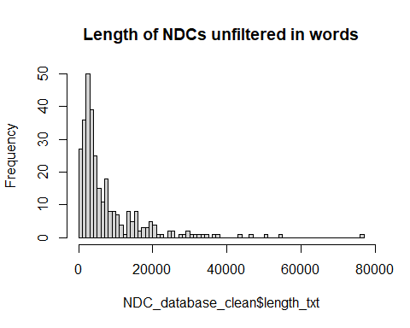

## Min. 1st Qu. Median Mean 3rd Qu. Max.   
## 93 2131 4013 7537 8827 73728

## Warning in NDC_subset$country == "EUU" & NDC_database_clean$version ==  
## "first_ndc": longer object length is not a multiple of shorter object length

## Warning: Removed 2 rows containing missing values (`geom_point()`).

## Warning: Removed 2 rows containing missing values (`geom_text()`).

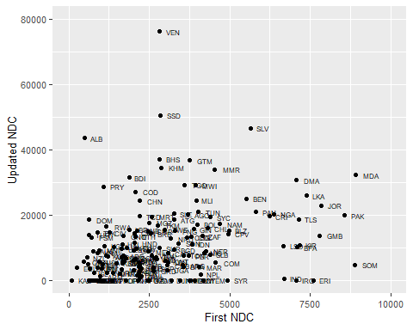

Prepare lemmatized and cleaned data dropping stopwords and rare words (appearing in less than 2 documents). The latter is typical for STM as rare words do not contribute much to clusters of words (topics).

As a result, we get the following message from the algorithm on data cleaning:

Removing 1123 of 8722 terms (3194 of 543096 tokens) due to frequency Your corpus now has 1280 documents, 7599 terms and 539902 tokens.

& test STM models for number of topics 3:50 As covariates I use version, conditionality, type, region and data on emisisons (version + Conditionality + Epc + Egdp + Echange + Type1 + Type2 + Type3 + AFRC + ASIA + BASC + CISP + EURP + LACA + OECD + SIDS)

## Min. 1st Qu. Median Mean 3rd Qu. Max.   
## 4.0 765.5 910.0 843.6 998.0 1234.0

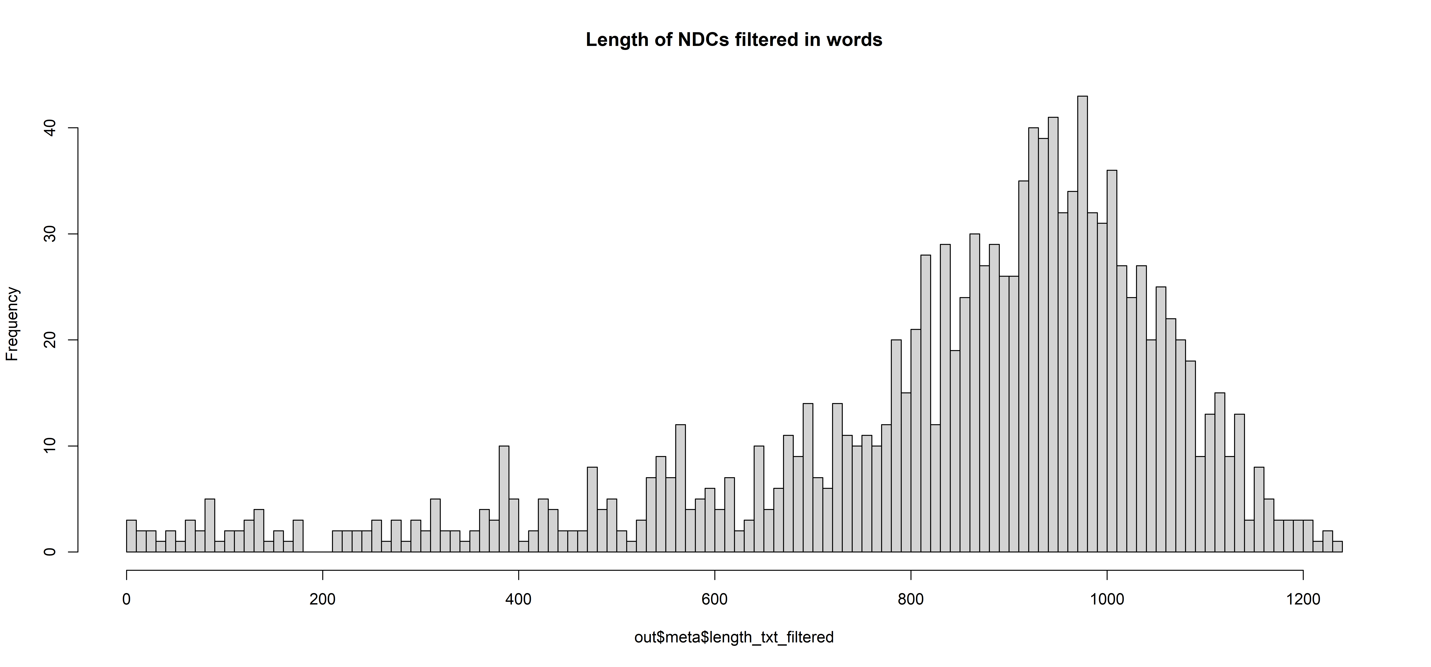

## [1] 7599

## vocab_app   
## [1,] "development" "1226"  
## [2,] "sector" "1217"  
## [3,] "action" "1175"  
## [4,] "use" "1175"  
## [5,] "include" "1174"  
## [6,] "plan" "1170"  
## [7,] "adaptation" "1128"  
## [8,] "implementation" "1124"  
## [9,] "base" "1120"  
## [10,] "increase" "1119"  
## [11,] "mitigation" "1117"  
## [12,] "level" "1106"  
## [13,] "measure" "1105"  
## [14,] "energy" "1102"  
## [15,] "policy" "1096"  
## [16,] "develop" "1092"  
## [17,] "resource" "1091"  
## [18,] "support" "1081"  
## [19,] "reduce" "1078"  
## [20,] "reduction" "1078"  
## [21,] "system" "1068"  
## [22,] "emission" "1061"  
## [23,] "management" "1059"  
## [24,] "sustainable" "1054"  
## [25,] "area" "1053"  
## [26,] "impact" "1050"  
## [27,] "project" "1046"  
## [28,] "strategy" "1045"  
## [29,] "economic" "1031"  
## [30,] "implement" "1028"  
## [31,] "agriculture" "1018"  
## [32,] "process" "1003"  
## [33,] "provide" "986"   
## [34,] "water" "984"   
## [35,] "capacity" "970"   
## [36,] "international" "970"   
## [37,] "land" "963"   
## [38,] "make" "940"   
## [39,] "need" "936"   
## [40,] "achieve" "933"   
## [41,] "activity" "922"   
## [42,] "government" "912"   
## [43,] "result" "904"   
## [44,] "source" "903"   
## [45,] "high" "902"   
## [46,] "global" "900"   
## [47,] "information" "899"   
## [48,] "target" "895"   
## [49,] "natural" "893"   
## [50,] "public" "892"   
## [51,] "improve" "881"   
## [52,] "environment" "874"   
## [53,] "community" "872"   
## [54,] "framework" "872"   
## [55,] "priority" "865"   
## [56,] "contribute" "859"   
## [57,] "new" "852"   
## [58,] "environmental" "842"   
## [59,] "forest" "832"   
## [60,] "population" "832"   
## [61,] "effort" "819"   
## [62,] "economy" "816"   
## [63,] "total" "816"   
## [64,] "report" "815"   
## [65,] "production" "809"   
## [66,] "technology" "807"   
## [67,] "planning" "802"   
## [68,] "potential" "802"   
## [69,] "key" "800"   
## [70,] "low" "798"   
## [71,] "data" "796"   
## [72,] "goal" "795"   
## [73,] "estimate" "789"   
## [74,] "ghg_emission" "789"   
## [75,] "relate" "789"   
## [76,] "objective" "787"   
## [77,] "social" "787"   
## [78,] "strengthen" "784"   
## [79,] "risk" "783"   
## [80,] "infrastructure" "781"   
## [81,] "technical" "781"   
## [82,] "promote" "779"   
## [83,] "take" "779"   
## [84,] "ensure" "775"   
## [85,] "resilience" "772"   
## [86,] "forestry" "771"   
## [87,] "carbon" "770"   
## [88,] "approach" "767"   
## [89,] "period" "763"   
## [90,] "financial" "761"   
## [91,] "health" "760"   
## [92,] "local" "758"   
## [93,] "one" "757"   
## [94,] "program" "757"   
## [95,] "waste" "755"   
## [96,] "establish" "752"   
## [97,] "investment" "752"   
## [98,] "set" "752"   
## [99,] "due" "748"   
## [100,] "work" "747"

##   
## Attaching package: 'wordcloud2'

## The following object is masked _by_ '.GlobalEnv':  
##   
## demoFreq

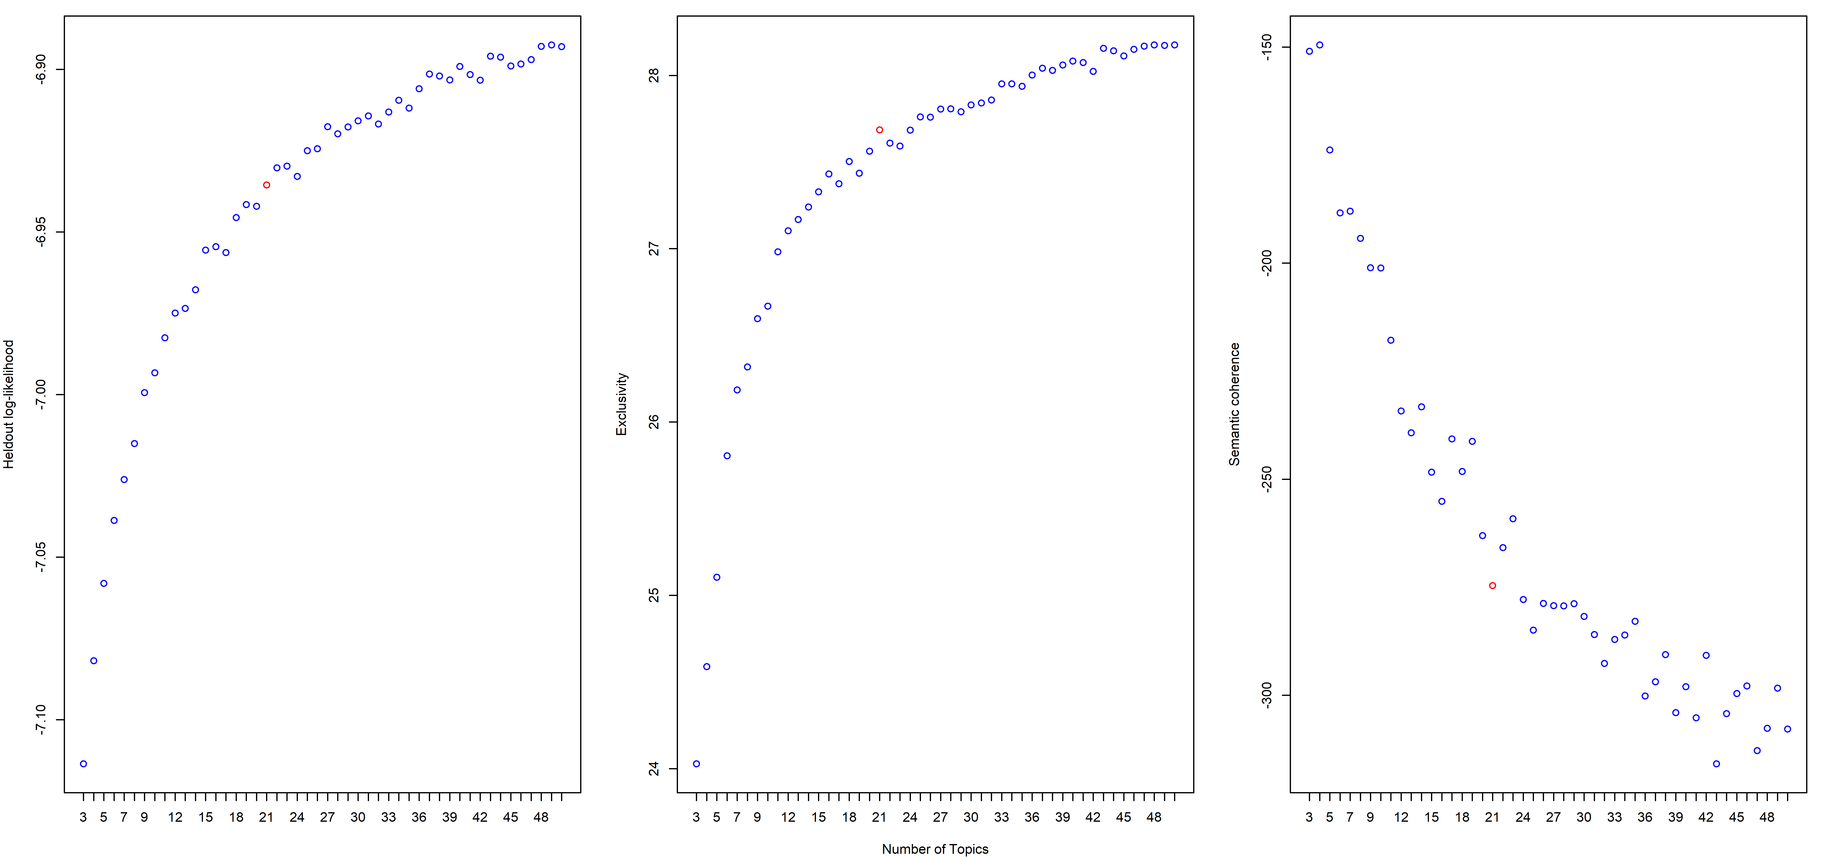

Here we observe:

* the figure with topic proportions, i.e. how much text explained by each of the topics;
* the figure with topic summary printing 10 most frequent and exclusive words for each topic;
* summary of each topic with words having highest probability (most frequent), frequency and exclusivity (FREX), LIFT and SCORE you can ignore as those are rather internal measures without intuitive interpretation;

We chose 20 topics 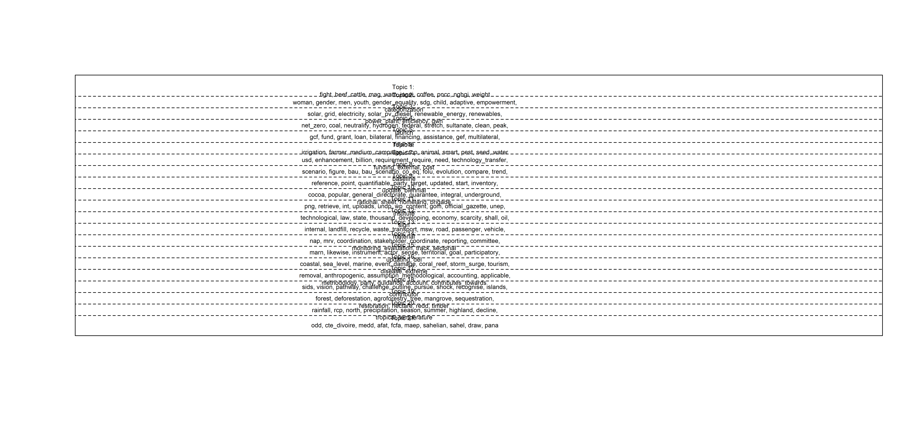

## Topic 18 Top Words:  
## Highest Prob: development, policy, emission, economic, sustainable, impact, plan, sector, action, global, growth, adaptation, government, economy, strategy, achieve, energy, increase, effort, high   
## FREX: sids, vision, pathway, challenge, outline, pursue, shock, recognise, islands, contributor, aspiration, much, upon, negligible, adverse, prosperous, ambitious, like, middle_income, pandemic   
## Lift: correctly, miniscule, proxy, goi, expanse, delicate, debt_restructuring, envisions, turmoil, dependant, overtime, incurs, monsoonal, resolute, irp, humankind, hon, classifies, lockdown, prominence   
## Score: sids, programme, islands, correctly, percent, pathway, atoll, recognise, emission, across, business_usual, per_caput, ambitious, livelihood, jnap, snc, development, commitment, resilience, nation   
## Topic 12 Top Words:  
## Highest Prob: development, energy, economic, emission, increase, state, measure, greenhouse_gas, economy, law, technological, international, water, sector, resource, strategy, environmental, reduce, plan, period   
## FREX: technological, law, state, thousand, developing, economy, scarcity, shall, oil, sign, ratify, accord, developed, framework_convention, task, main, thus, greenhouse_gas, legal, decrease   
## Lift: eurasian, mudflows, technological, aral_sea, soviet, dust_storm, military, combating, blockade, specified, terrorist, amounted, virtuous, reconstruct, traction, destiny, foothill, plausible, attache, readjustment   
## Score: technological, aral_sea, law, oil, gas, gdp, greenhouse_gas, scarcity, energy, emission, framework_convention, conference_party, dust_storm, intensity, shall, accordance, decrease, per_caput, blockade, terrorist   
## Topic 17 Top Words:  
## Highest Prob: emission, use, approach, include, party, removal, greenhouse_gas, applicable, level, information, guideline, estimate, global, methodology, target, account, inventory, anthropogenic, reduction, land   
## FREX: removal, anthropogenic, assumption_methodological, accounting, applicable, methodology, party, guidance, account, contributes_towards, consistent, approach, disturbance, harvest_wood, assumption, metric, accordance, tier, guideline, considers_fair   
## Lift: fairness_consideration, kp_supplement, overshoot, considers_fair, forcers, iii_forcers, administrator, avoidance_double, class_structure, disturbance_managed, prescribed, ratchet, contributes_towards, deadwood, assumption_methodological, age_class, regrowth, harvest_wood, hwp, voluntary_cooperation   
## Score: assumption_methodological, contributes_towards, applicable, removal, party, act_jointly, age_class, considers_fair, anthropogenic, forcers, emission, harvest_wood, fairness_consideration, voluntary_cooperation, administrator, iii_forcers, disturbance, disturbance_managed, methodology, assumption   
## Topic 7 Top Words:  
## Highest Prob: mitigation, adaptation, support, need, action, implementation, million, cost, international, usd, estimate, sector, investment, require, financial, billion, technology, measure, implement, finance   
## FREX: usd, enhancement, billion, requirement, require, need, technology_transfer, funding, external, cost, capacity_building, million, financial, investment, finance, budget, estimate, conditional, tcoe, transfer   
## Lift: enhancement, bnccc, suppressed, cubic_foot, stp, sufficiency, intellectual_property, frel_frl, ordination, adequacy, prioritised, usd, eep, nrs, upfront, optional, wooden, rcc, convey, oda   
## Score: enhancement, usd, billion, stp, conditional, million, mitigation, programme, tcoe, adaptation, unconditional, capacity_building, technology_transfer, need, support, cost, estimate, finance, mrv, investment   
## Topic 8 Top Words:  
## Highest Prob: emission, sector, scenario, ghg_emission, mitigation, reduction, use, energy, waste, figure, table, agriculture, total, measure, ghg, compare, increase, base, bau, conditional   
## FREX: scenario, figure, bau, bau_scenario, co_eq, folu, evolution, compare, trend, baseline, show, table, calculate, projection, gg_coeq, unconditional, ghg_emission, emission, absorption, exclude   
## Lift: excel_spreadsheet, ggcoe_ggcoe, summarizes, fermentation, legend, mule, ipup, fine_particle, envisioned, particle, prg, kilo_tonne, pfc_sf, gg_coeq, organic_compound, counterfactual, dense_humid, arboriculture, deduct, oui   
## Score: emission, bau, scenario, bau_scenario, folu, ghg_emission, figure, legend, conditional, unconditional, fat, co_eq, gg_coeq, kt_coe, compare, business_usual, ggcoe, piup, sector, table   
## Topic 14 Top Words:  
## Highest Prob: adaptation, action, implementation, sector, plan, development, policy, strategy, level, process, data, system, ministry, include, implement, stakeholder, sectoral, develop, framework, resource   
## FREX: nap, mrv, coordination, stakeholder, coordinate, reporting, committee, monitoring_evaluation, track, sectorial, sectoral, cca, monitor, mainstreaming, data, institutional_arrangement, expert, institutional, monitoring, civil_society   
## Lift: fed, swg, fora, assessing, implementable, strengths, cca, nccc, sap, financier, moepd, steer_committee, summarises, oversee, wealthy, organisational, multistakeholder, tag, outreach, iterative   
## Score: cca, mrv, nap, adaptation, stakeholder, fed, mainstreaming, track, nccc, implementation, sectorial, coordination, reporting, ministry, partner, action, data, committee, engagement, institutional_arrangement   
## Topic 16 Top Words:  
## Highest Prob: water, adaptation, impact, health, risk, increase, coastal, infrastructure, sector, area, plan, event, management, include, tourism, vulnerability, resilience, ecosystem, flood, marine   
## FREX: coastal, sea_level, marine, event, damage, coral_reef, storm_surge, tourism, disease, extreme, flooding, loss_damage, beach, storm, flood, hazard, extreme_weather, erosion, risk, health   
## Lift: exacerbation, purse, ridge_reef, demarcate, freshwater_lens, deadly, droughts, coral_bleach, algal_bloom, impend, malaria_dengue, fog, diarrhea, beach, observational, acidification, coral_reef, casualty, saltwater_intrusion, rodent   
## Score: sea_level, coastal, storm_surge, marine, loss_damage, beach, disaster, tourism, coral_reef, drought, fishery, disease, flood, water, rise, event, vulnerability, flooding, hazard, exacerbation   
## Topic 9 Top Words:  
## Highest Prob: target, include, update, reference, sector, information, emission, party, plan, mitigation, inventory, ghg_emission, implementation, report, base, action, measure, process, reduction, data   
## FREX: reference, point, quantifiable, party, target, updated, start, inventory, update, biennial, time_frame, express, quantify, scope_coverage, submit, applicable, decision_cma, diversification, ictu, pool   
## Lift: whether_single, carbonization, refer_police, rigorously, undertook_prepare, compound_nmvoc, quantifiable, scope_coverage, serve_meeting, circumstance_geography, recalculation, recalculate, sulphur_sf, ictu, completeness_accuracy, indicators, explanation, time_frame, outboard, january_december   
## Score: carbonization, party, reference, target, applicable, whether_single, undertook_prepare, circumstance_geography, inventory, act_jointly, quantifiable, contextual_matter, gg_coe, cma, biennial, scope_coverage, serve_meeting, ictu, decision_cma, refer_police   
## Topic 20 Top Words:  
## Highest Prob: increase, temperature, population, area, rainfall, high, average, drought, annual, region, precipitation, low, sector, impact, affect, water, rise, rate, decrease, result   
## FREX: rainfall, rcp, north, precipitation, season, summer, highland, decline, tropical, temperature, month, wet, dry_season, northern, rain, rainy_season, frequency, eastern, coast, winter   
## Lift: decadal, depressed, egg, ensemble, giant, intercomparison, itcz, pelagic, santa_isabel, score, rcps, confine, sst, volcanic_origin, westerly, summer_autumn, intersperse, grape, recorded, pronounced   
## Score: score, rainfall, rcp, precipitation, principality, drought, temperature, percent, summer, tropical, highland, rcp_rcp, sea_level, specie, decline, aez, winter, ensemble, north, aezs   
## Topic 4 Top Words:  
## Highest Prob: emission, carbon, energy, government, green, technology, new, plan, reduction, target, development, policy, low_carbon, include, action, reduce, clean, support, industry, goal   
## FREX: net_zero, coal, neutrality, hydrogen, federal, stretch, sultanate, clean, peak, launch, nuclear, trading, provincial, deployment, innovation, low_carbon, demonstration, accelerate, pricing, green   
## Lift: routine_flaring, arctic, nuclear, sultanate, fellow, tighten, nbs, emirate, scp, mankind, ontario, lagos, vigorously, legislate, ndma, outstanding, enlarge, exhibition, stretch, shared   
## Score: nuclear, sultanate, net_zero, stretch, coal, emirate, hydrogen, emission, petrochemical, carbon, scp, ontario, federal, sar, low_carbon, mankind, across, provincial, pams, trading   
## Topic 15 Top Words:  
## Highest Prob: adaptation, goal, action, sector, process, development, implementation, mitigation, update, plan, commitment, measure, establish, make, framework, level, management, information, objective, present   
## FREX: marn, likewise, instrument, actor, sense, territorial, goal, participatory, updating, del, respect, transversal, fulfillment, mother_earth, allow, among_others, compliance, seek, ingei, agenda   
## Lift: agropecuario, ante, bibliographic, cicc, conceptualization, datos, desarrollo_con, efecto, encc, estudio, inec, ingeis, institutionality, invernadero, isthmus, miambiente, mitch, multisectoral_multilevel, pancc, ratifies   
## Score: marn, ingei, ministerio, mother_earth, del, miambiente, plurinational, cncc, afro, crc, aecid, transversal, congress, territorial, inec, pancc, contemplate, commitment, iba, conceptualization   
## Topic 3 Top Words:  
## Highest Prob: energy, electricity, efficiency, renewable_energy, solar, power, action, generation, mitigation, use, reduction, increase, sector, reduce, capacity, system, project, grid, efficient, emission   
## FREX: solar, grid, electricity, solar_pv, diesel, renewable_energy, renewables, power_plant, efficiency, gwh, renewable, hydro, installation, appliance, wind, instal, installed, photovoltaic, mix, electric   
## Lift: composition, incandescent_bulb, appropriateness, incandescent, substation, bulbs, wash_machine, ethanol_blend, nui, heater, ecreee, solar_pv, electrified, electrify, bagasse, mini_grid, cfl, gallon, gwh, bundle   
## Score: composition, solar, energy, grid, renewable_energy, electricity, solar_pv, gwh, mini_grid, appropriateness, appliance, electric_vehicle, photovoltaic, renewables, diesel, fuel, efficiency, mix, wind, heater   
## Topic 19 Top Words:  
## Highest Prob: forest, area, land, management, carbon, use, conservation, ecosystem, sustainable, forestry, deforestation, biodiversity, protect, cover, restoration, natural, increase, tree, community, reduce   
## FREX: forest, deforestation, agroforestry, tree, mangrove, sequestration, restoration, hectare, redd, timber, protected, uc_u, reforestation, degradation, conservation, degraded, landscape, biodiversity, protect, restore   
## Lift: sfm, enclosure, pollination, uc_u, reforested, traceability, aichi, hfld, estate, mangroves, treasure, canopy, illegal_logging, forestlands, remote_sensing, deforested, inside_outside, timber, refuge, agroforestry   
## Score: forest, uc_u, sfm, deforestation, redd, tree, agroforestry, reforestation, restoration, mangrove, specie, carbon, plantation, land, conservation, ecosystem, timber, frl, sequestration, degraded   
## Topic 5 Top Words:  
## Highest Prob: support, project, development, fund, capacity, finance, management, investment, government, technology, financial, adaptation, sector, develop, financing, include, implementation, private, resilience, program   
## FREX: gcf, fund, grant, loan, bilateral, financing, assistance, gef, multilateral, finance, donor, readiness, investor, trust, spcr, caribbean, bond, debt, donation, bank   
## Lift: danida, debt_swap, etsel_romit, internship, backing, bi_lateral, ppps, modernization_upliftment, fiduciary, tac, disbursement, greenclimate, concessional_loan, ncsa, slop, donation, kap, brown, premium, lending   
## Score: fund, gcf, spcr, donation, concessional_loan, caribbean, danida, finance, disbursement, implementing_entity, financing, loan, oecs, etsel_romit, support, programme, gef, bilateral, bond, donor   
## Topic 21 Top Words:  
## Highest Prob: development, project, sector, program, adaptation, implementation, plan, objective, sustainable, cost, resource, energy, action, agriculture, strengthen, strategy, mitigation, unconditional, conditional, million   
## FREX: odd, cte_divoire, medd, afat, fcfa, maep, sahelian, sahel, draw, pana, niveau, indeed, reinforcement, denterminee_au, pastoral, essentially, horizon, locality, agro_pastoral, des   
## Lift: medd, niveau, accentuation, aep, afrique, agricoles, aic, cadre_stratgique, capacits, cni, croissance, dtermine, du_secteur, eaux, ebt, enemy, environnementale, epizootics, fem, fonds   
## Score: odd, cte_divoire, afat, maep, medd, fcfa, de_la, lenergie, sahelian, niveau, denterminee_au, socit, des, lutte_contre, unconditional, pana, piup, politique, sahel, abbyy   
## Topic 6 Top Words:  
## Highest Prob: water, high, management, agriculture, agricultural, improve, system, resource, medium, sector, livestock, development, promote, production, crop, increase, use, area, resilience, adaptation   
## FREX: irrigation, farmer, medium, campaign, crop, animal, smart, pest, seed, water, high, livestock, variety, aquaculture, early_warning, drinking, value_chain, food_security, nutrition, dam   
## Lift: aqua, folk, multipurpose_dam, campaign, eroded, drip, pastoralist, varietal, ipm, cultivar, env, composting_biodegradable, passive_cooling, tolerant, silo, sprinkler, restoring, investing, abstraction, mechanization   
## Score: campaign, water, crop, irrigation, livestock, env, farmer, pasture, medium, animal, fishery, pest, agriculture, agricultural, high, tolerant, aquaculture, drought, improve, management   
## Topic 13 Top Words:  
## Highest Prob: sector, waste, transport, use, reduce, emission, industry, energy, increase, industrial, policy, fuel, implement, production, management, building, vehicle, gas, road, infrastructure   
## FREX: internal, landfill, recycle, waste, transport, msw, road, passenger, vehicle, material, rail, cement, railway, recycling, bus, scp_hat, compost, plastic, treatment, petroleum   
## Lift: biofuels_refuse, dumpsite, expressway, internal, ride, textile_apparel, slag, motorized, vehicular, leachate, multimodal, deep_placement, lane, cradle, walking, rdf_anaerobic, lfg, scrap, fly_ash, mining_quarry   
## Score: internal, scp_hat, percent, waste, landfill, vehicle, fuel, transport, msw, cement, passenger, principality, recycle, bus, gas, building, compost, plastic, car, oil   
## Topic 11 Top Words:  
## Highest Prob: ministry, development, environment, report, nation, unfccc, agriculture, new, plan, png, department, global, energy, undp, resource, institute, government, forestry, international, management   
## FREX: png, retrieve, int, uploads, undp, wp_content, gom, official_gazette, unep, institute, nacional, gov, fao, sit_default, royal, ministry, directorate, html, nation, ine   
## Lift: ambiental, giz_deutsche, royal, sistemas, nov, censo, retrieve, eds, png, natc, collins, smith, recursos, resultados, merge, cambridge_university, programa, politica, iadb, wp_content   
## Score: png, royal, retrieve, official_gazette, gom, ministry, wp_content, de_la, int, nacional, uploads, los, recursos, gov, nation, bosques, documentos, programme, sit_default, december   
## Topic 2 Top Words:  
## Highest Prob: woman, gender, adaptation, measure, impact, action, risk, plan, improve, development, youth, information, health, social, vulnerability, sector, planning, capacity, community, system   
## FREX: woman, gender, men, youth, gender_equality, sdg, child, adaptive, empowerment, categorization, knowledge, decision_making, snrcc, sdgs, inequality, girl, gender_responsive, city, loss_damage, young_people   
## Lift: cater, tv_radio, intersectionality, siem_reap, leverage_decentralization, nccp_potentially, teaching, disaggregated_sex, marginalize, boy, disable, sfdrr, broadcasting, intersectional, categorization, woman, derived, plata_atlantic, esp, men   
## Score: woman, gender, cater, snrcc, categorization, nccp_potentially, men, gender_equality, youth, gender_responsive, sdg, mme, loss_damage, child, pncc, vulnerability, engagement, girl, leverage_decentralization, marginalize   
## Topic 10 Top Words:  
## Highest Prob: sector, action, plan, policy, development, update, promote, environmental, objective, system, program, management, use, sustainable, people, power, institution, ministry, impact, public   
## FREX: cocoa, popular, general_directorate, guarantee, integral, underground, rational, sheet, homeland, brigade, socialist, educational, substance, execution, laboratory, socio, biological_diversity, planet, ozone_layer, sovereignty   
## Lift: francisco, california, corporacin_del, mara, navegacin, rafael, universidad_nacional, daro, brigade, undergraduate, cacao, president_nicols, popular, corporacin, enjoyment, interrelate, socialist, compensatory, conformation, homeland   
## Score: popular, brigade, socialist, california, cocoa, general_directorate, socialism, de_la, cnd, corporacin, homeland, capitalist, navegacin, rational, cacao, underground, iec, corporacin_del, fundacin, compensatory   
## Topic 1 Top Words:  
## Highest Prob: measure, mitigation, fight, implementation, area, sector, reduction, production, emission, use, system, include, ghg_emission, land, base, agricultural, objective, plan, management, intensity   
## FREX: fight, beef, cattle, mag, wam, ingei, coffee, pncc, nghgi, weight, manifestation, gwp_ar, intensity, silvopastoral, grassland, variability, native, producer, plantation, matrix   
## Lift: fight, rotation_length, shade_shelter, breeding_herd, earlier_deem, nghgi, adolescent_young, wam, corn_bean, beef, soybean, noviembre_hydroelectric, cane, gwp_ar, alcohol, electro, bovine, digestibility, rancher, mosaic   
## Score: fight, ingei, mag, beef, wam, nghgi, gwp_ar, shade_shelter, rotation_length, pncc, mosaic, cattle, marn, corn_bean, breeding_herd, adolescent_young, ancestral, intensity, plantation, pasture

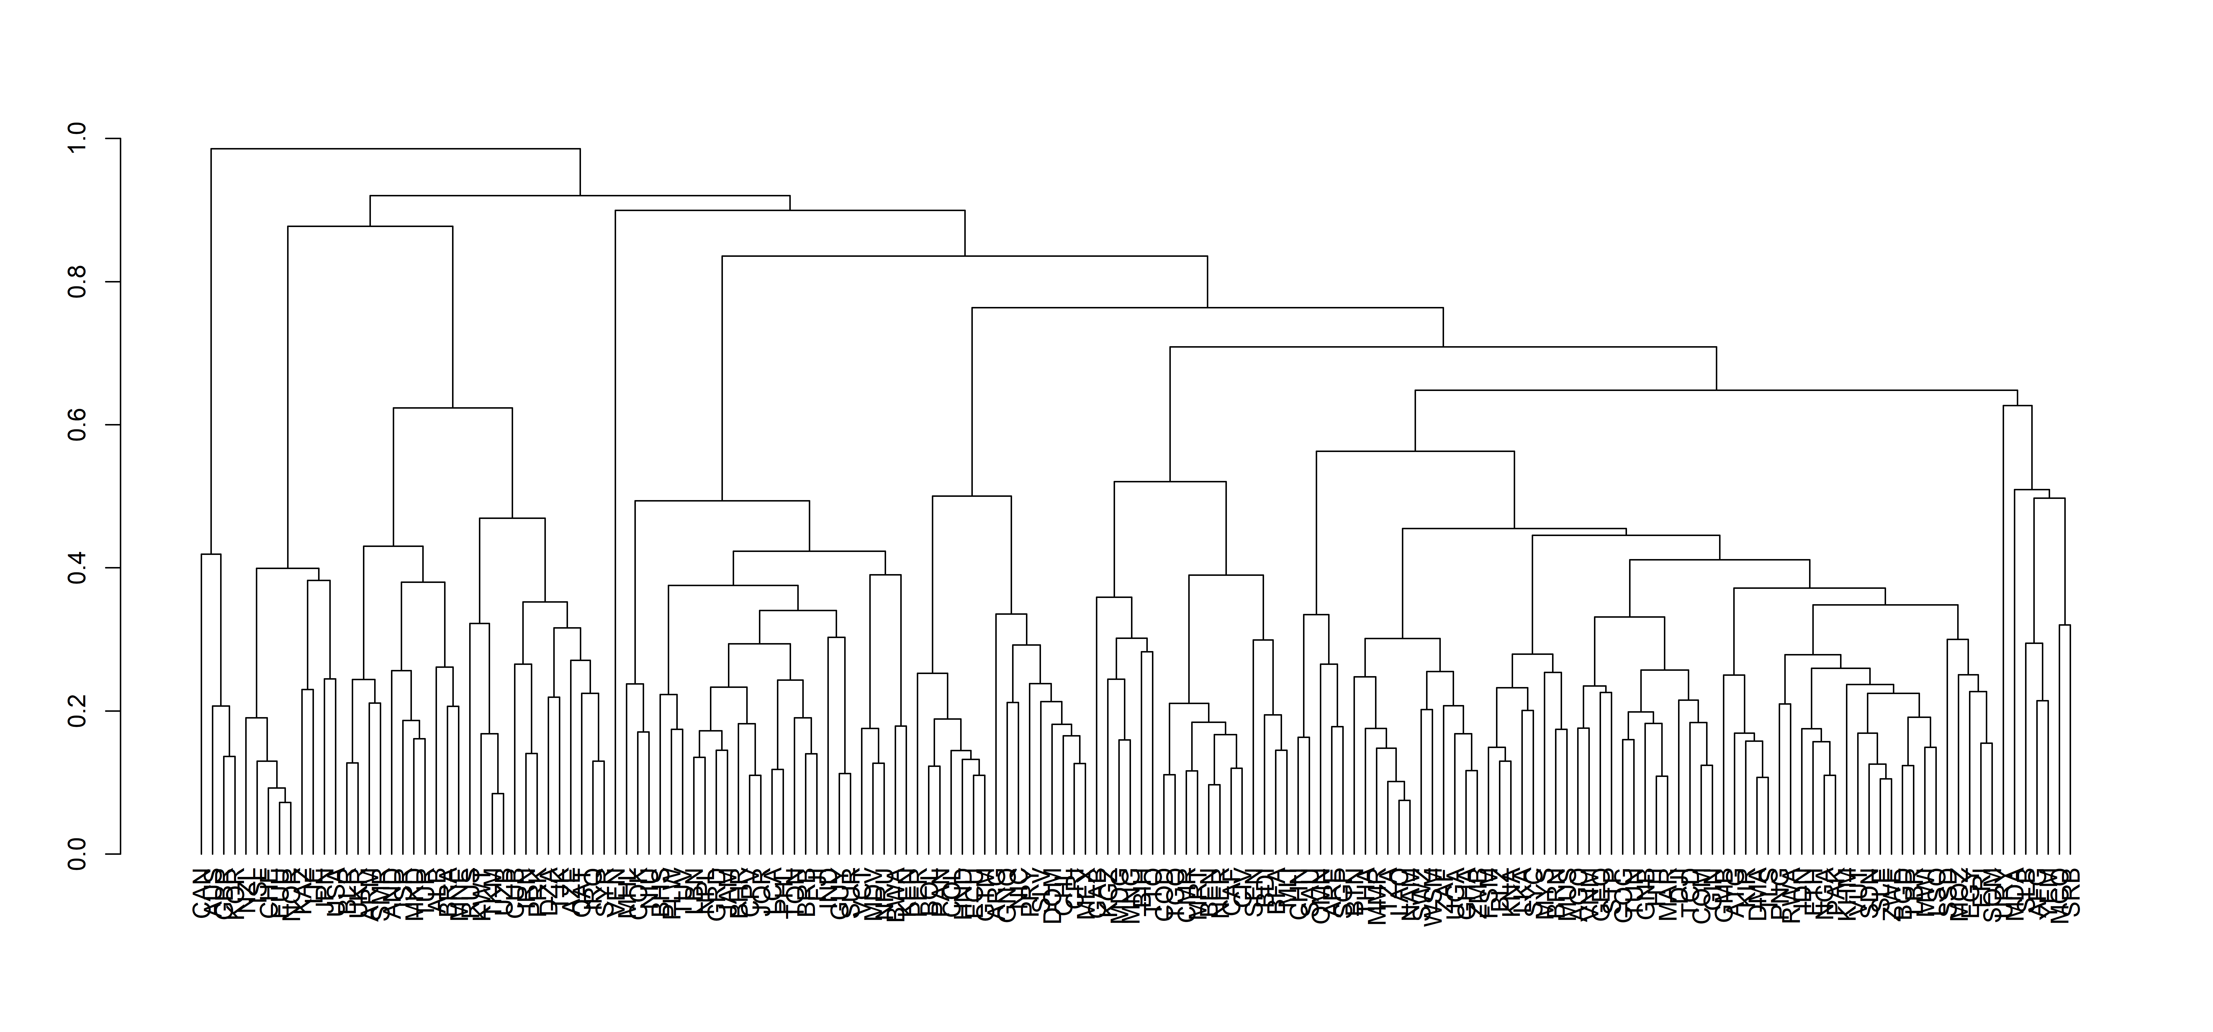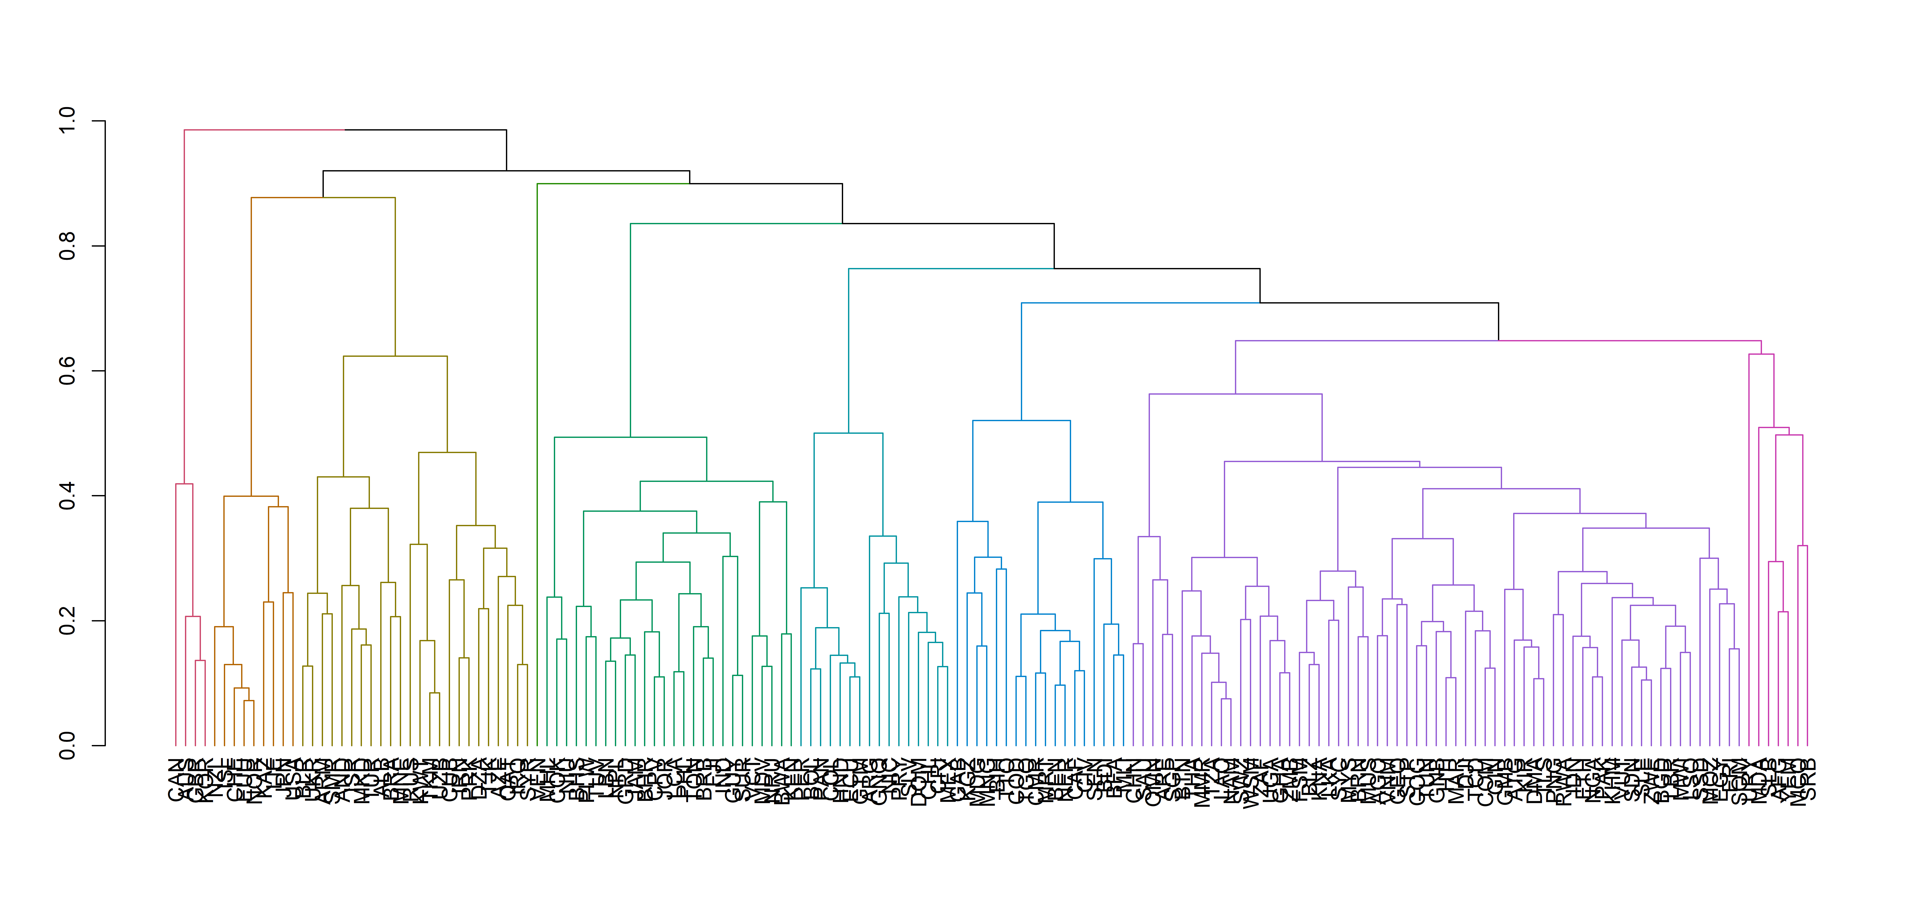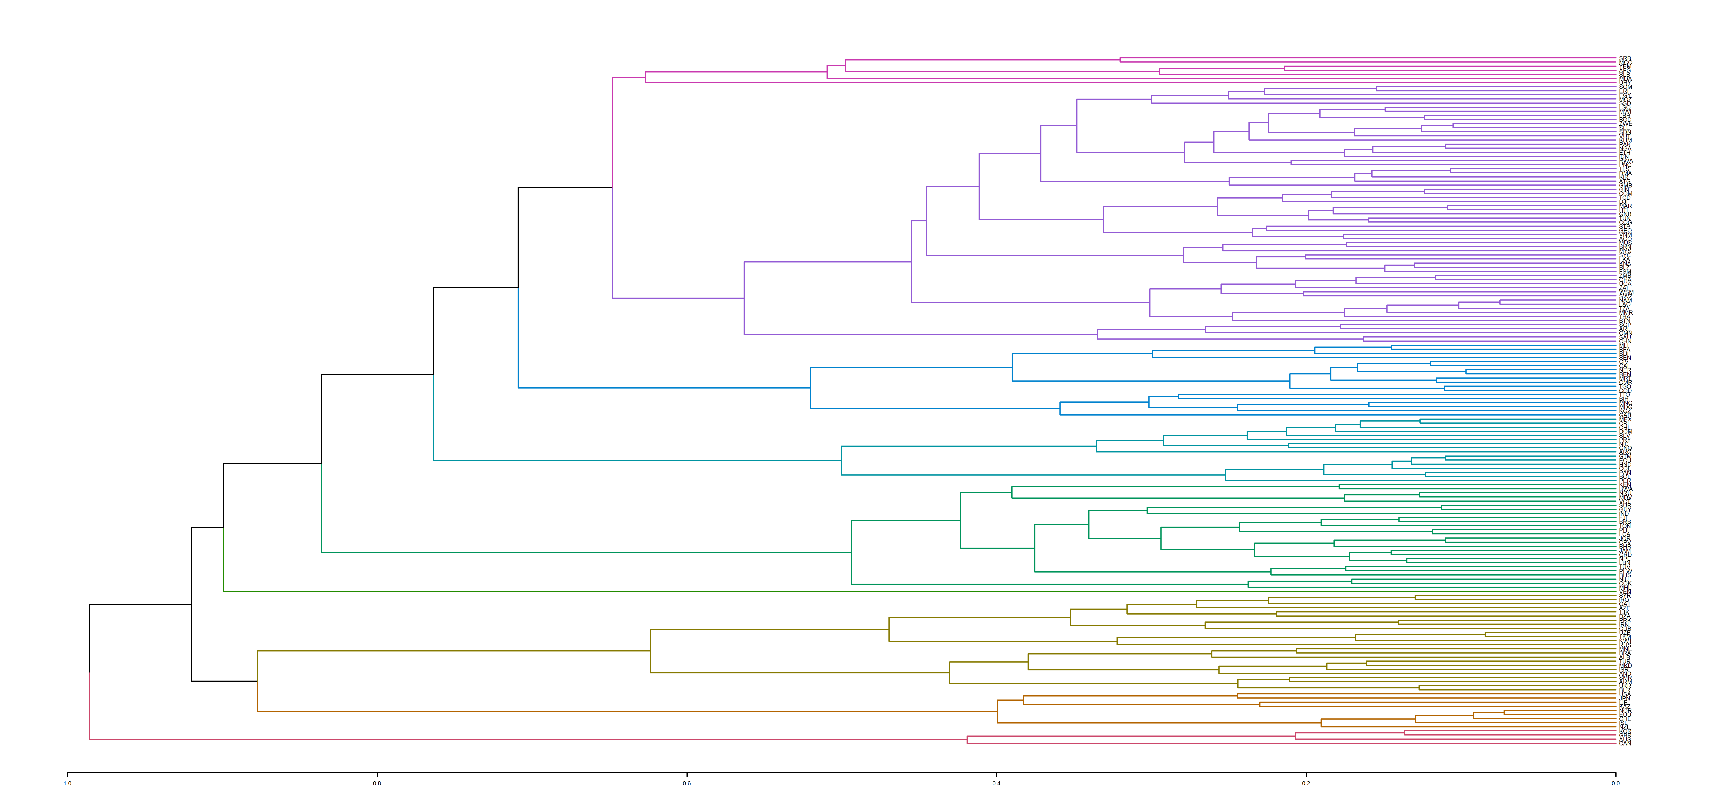

## Warning: package 'ape' was built under R version 4.3.2

##   
## Attaching package: 'ape'

## The following objects are masked from 'package:igraph':  
##   
## degree, edges, mst, ring

## The following object is masked from 'package:ggpubr':  
##   
## rotate

## The following objects are masked from 'package:dendextend':  
##   
## ladderize, rotate

## The following object is masked from 'package:dplyr':  
##   
## where

## Warning: package 'circlize' was built under R version 4.3.2

## ========================================  
## circlize version 0.4.15  
## CRAN page: https://cran.r-project.org/package=circlize  
## Github page: https://github.com/jokergoo/circlize  
## Documentation: https://jokergoo.github.io/circlize_book/book/  
##   
## If you use it in published research, please cite:  
## Gu, Z. circlize implements and enhances circular visualization  
## in R. Bioinformatics 2014.  
##   
## This message can be suppressed by:  
## suppressPackageStartupMessages(library(circlize))  
## ========================================

##   
## Attaching package: 'circlize'

## The following object is masked from 'package:ape':  
##   
## degree

## The following object is masked from 'package:igraph':  
##   
## degree

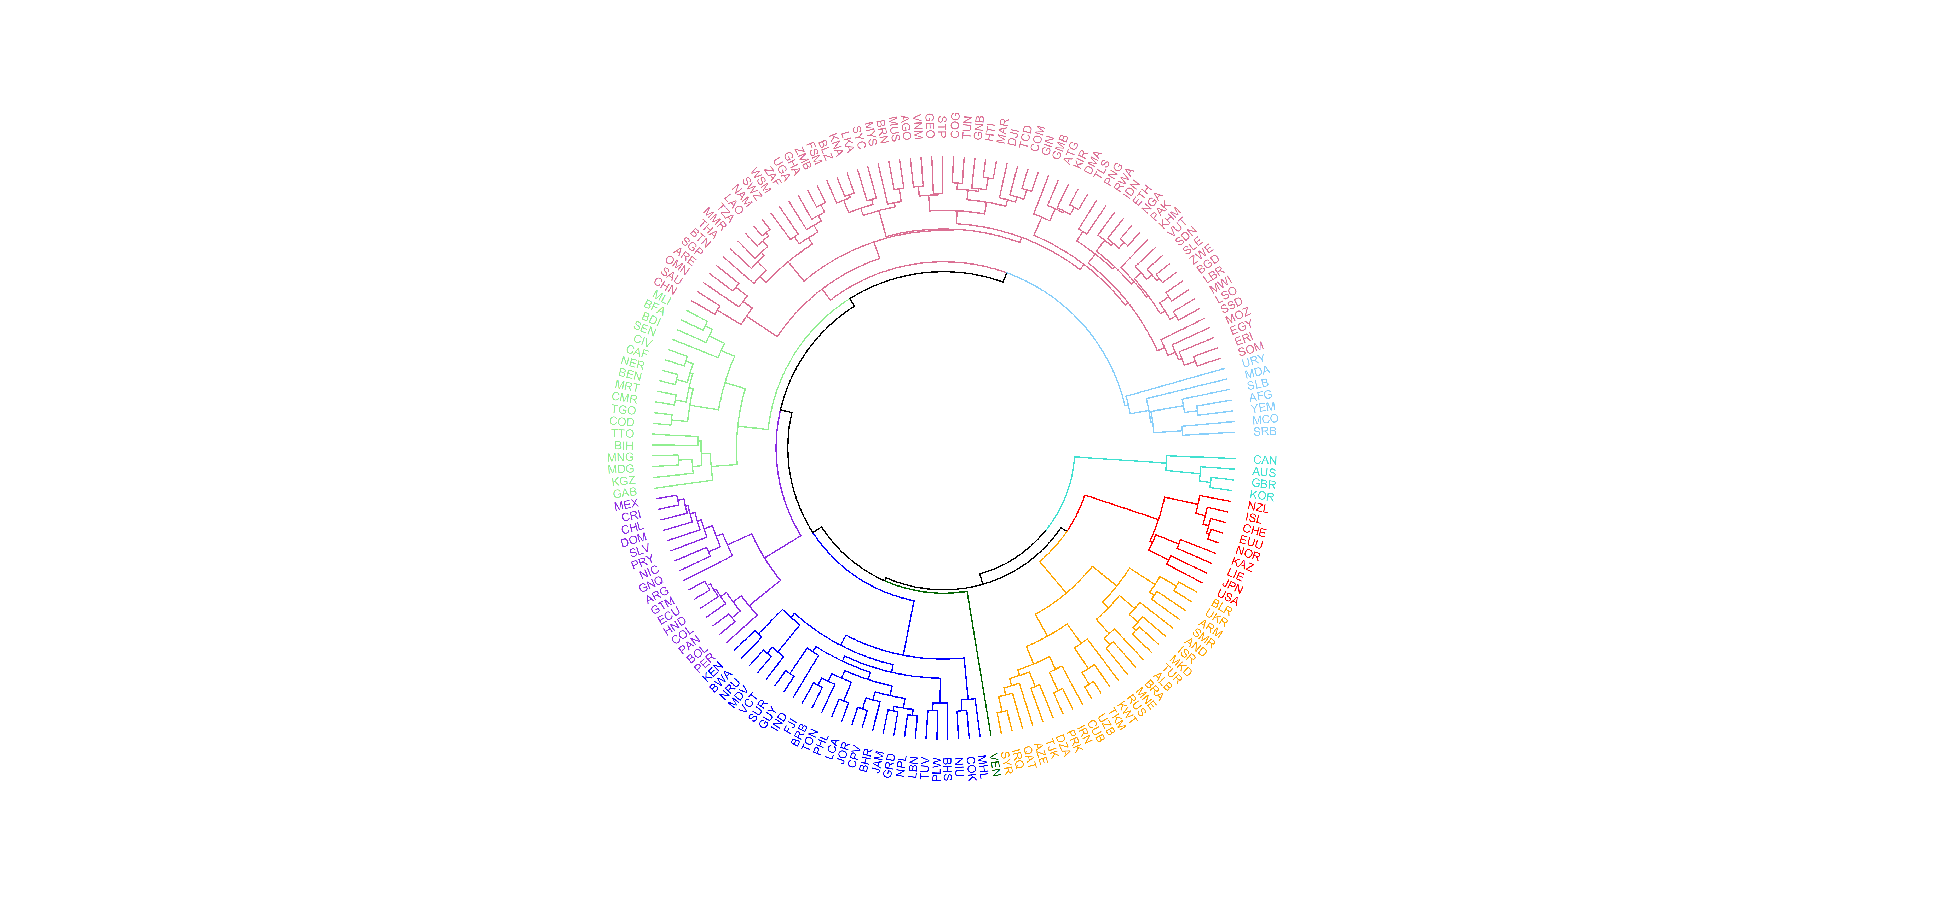

## groups  
## 1 2 3 4 5 6 7 8 9   
## 7 63 24 16 4 18 26 9 1

## AFG MCO MDA SLB SRB URY YEM   
## 1 1 1 1 1 1 1

## AGO ARE ATG BGD BLZ BRN BTN CHN COG COM DJI DMA EGY ERI ETH FSM GEO GHA GIN GMB   
## 2 2 2 2 2 2 2 2 2 2 2 2 2 2 2 2 2 2 2 2   
## GNB HTI IDN KHM KIR KNA LAO LBR LKA MAR MMR MOZ MUS MWI MYS NAM NGA OMN PAK PNG   
## 2 2 2 2 2 2 2 2 2 2 2 2 2 2 2 2 2 2 2 2   
## RWA SAU SDN SGP SLE SOM SSD STP SWZ SYC TCD THA TLS TUN TZA UGA VNM VUT WSM ZAF   
## 2 2 2 2 2 2 2 2 2 2 2 2 2 2 2 2 2 2 2 2   
## ZMB ZWE LSO   
## 2 2 2

## ALB AND ARM AZE BLR BRA CUB DZA IRN IRQ ISR KWT MKD MNE PRK QAT RUS SMR SYR TJK   
## 3 3 3 3 3 3 3 3 3 3 3 3 3 3 3 3 3 3 3 3   
## TKM TUR UKR UZB   
## 3 3 3 3

## ARG BOL CHL COL CRI DOM ECU GNQ GTM HND MEX NIC PAN PER PRY SLV   
## 4 4 4 4 4 4 4 4 4 4 4 4 4 4 4 4

## AUS CAN GBR KOR   
## 5 5 5 5

## BDI BEN BFA BIH CAF CIV CMR COD GAB KGZ MDG MLI MNG MRT NER SEN TGO TTO   
## 6 6 6 6 6 6 6 6 6 6 6 6 6 6 6 6 6 6

## BHR BHS BRB BWA COK CPV FJI GRD GUY IND JAM JOR KEN LBN LCA MDV MHL NIU NPL NRU   
## 7 7 7 7 7 7 7 7 7 7 7 7 7 7 7 7 7 7 7 7   
## PHL PLW SUR TON TUV VCT   
## 7 7 7 7 7 7

## CHE EUU ISL JPN KAZ LIE NOR NZL USA   
## 8 8 8 8 8 8 8 8 8

## VEN   
## 9

## VEN   
## 11

## AUS CAN GBR KOR   
## 12 12 12 12

## CHE EUU ISL JPN KAZ LIE NOR NZL USA   
## 13 13 13 13 13 13 13 13 13

## AFG MCO MDA SLB SRB URY YEM   
## 14 14 14 14 14 14 14

## AGO ARE ATG BGD BLZ BRN BTN CHN COG COM DJI DMA EGY ERI ETH FSM GEO GHA GIN GMB   
## 15 15 15 15 15 15 15 15 15 15 15 15 15 15 15 15 15 15 15 15   
## GNB HTI IDN KHM KIR KNA LAO LBR LKA MAR MMR MOZ MUS MWI MYS NAM NGA OMN PAK PNG   
## 15 15 15 15 15 15 15 15 15 15 15 15 15 15 15 15 15 15 15 15   
## RWA SAU SDN SGP SLE SOM SSD STP SWZ SYC TCD THA TLS TUN TZA UGA VNM VUT WSM ZAF   
## 15 15 15 15 15 15 15 15 15 15 15 15 15 15 15 15 15 15 15 15   
## ZMB ZWE LSO   
## 15 15 15

## ARG BOL CHL COL CRI DOM ECU GNQ GTM HND MEX NIC PAN PER PRY SLV   
## 16 16 16 16 16 16 16 16 16 16 16 16 16 16 16 16

## BDI BEN BFA BIH CAF CIV CMR COD GAB KGZ MDG MLI MNG MRT NER SEN TGO TTO   
## 17 17 17 17 17 17 17 17 17 17 17 17 17 17 17 17 17 17

## ALB AND ARM AZE BLR BRA CUB DZA IRN IRQ ISR KWT MKD MNE PRK QAT RUS SMR SYR TJK   
## 18 18 18 18 18 18 18 18 18 18 18 18 18 18 18 18 18 18 18 18   
## TKM TUR UKR UZB   
## 18 18 18 18

## BHR BHS BRB BWA COK CPV FJI GRD GUY IND JAM JOR KEN LBN LCA MDV MHL NIU NPL NRU   
## 19 19 19 19 19 19 19 19 19 19 19 19 19 19 19 19 19 19 19 19   
## PHL PLW SUR TON TUV VCT   
## 19 19 19 19 19 19

## Warning: package 'gridExtra' was built under R version 4.3.2

##   
## Attaching package: 'gridExtra'

## The following object is masked from 'package:dplyr':  
##   
## combine

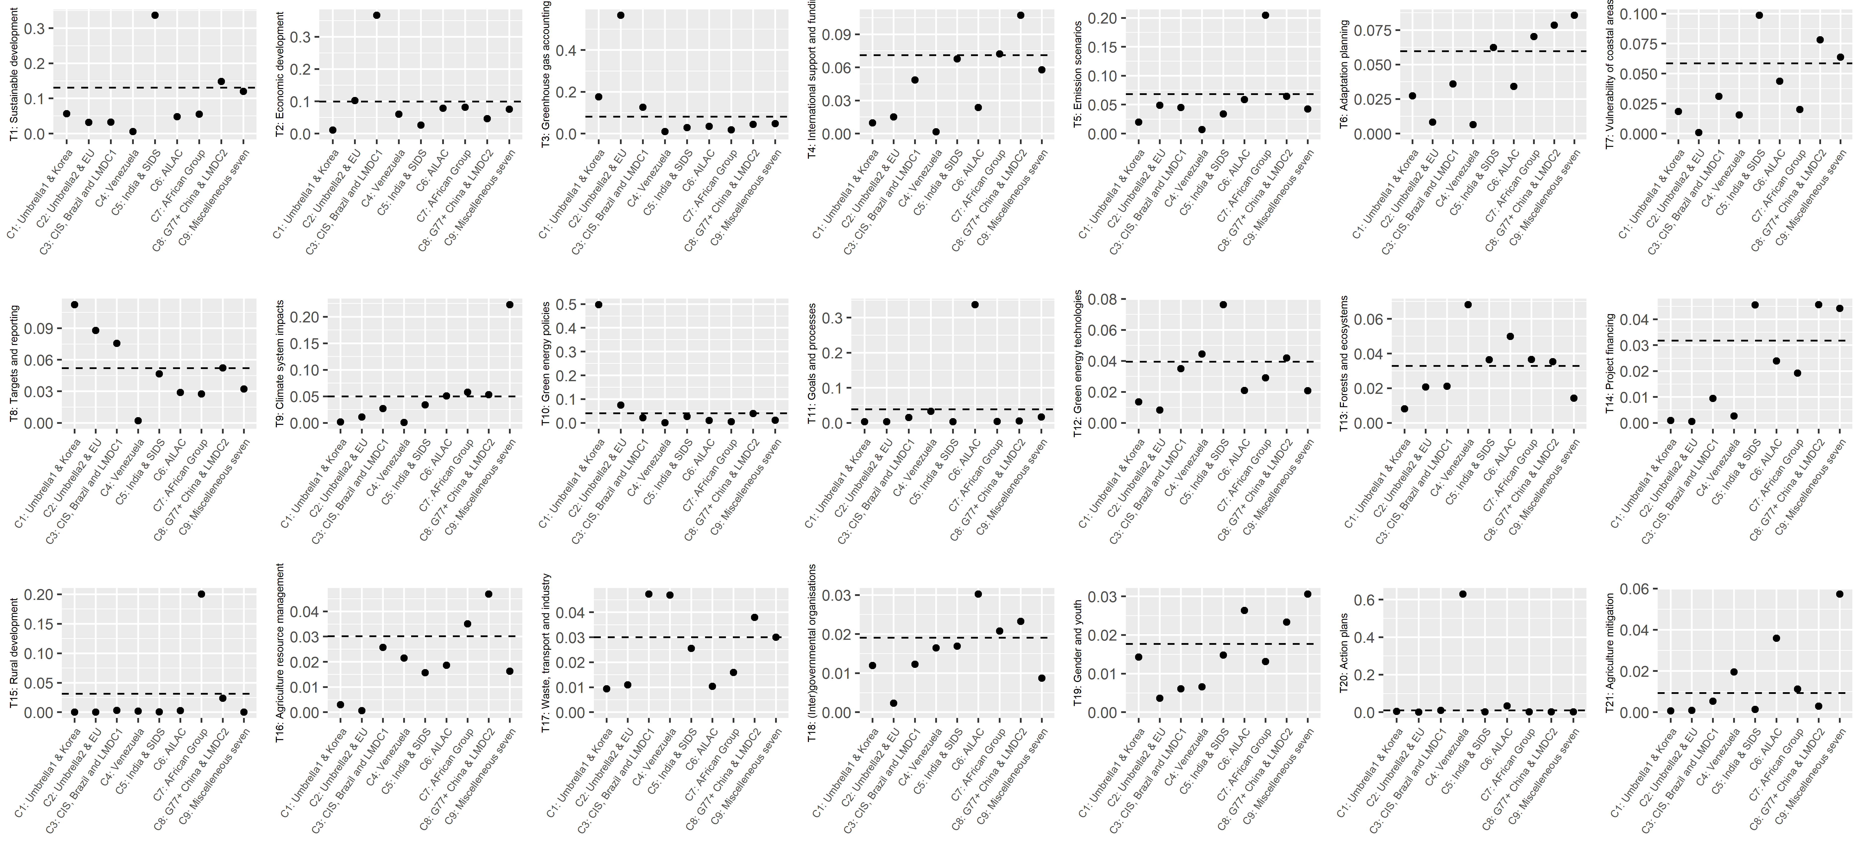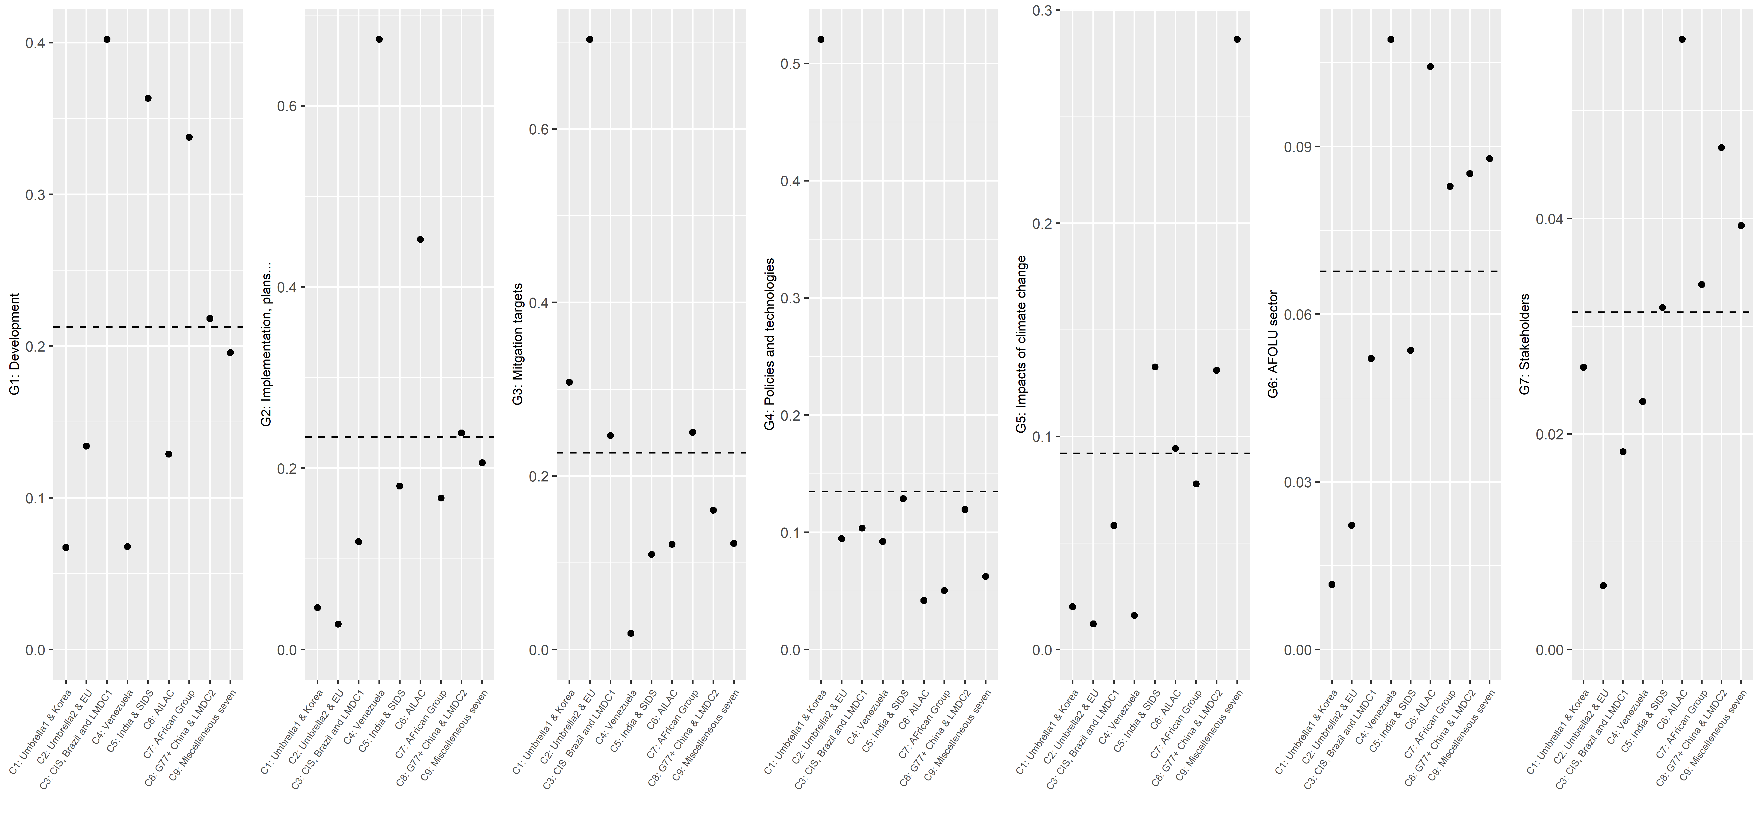

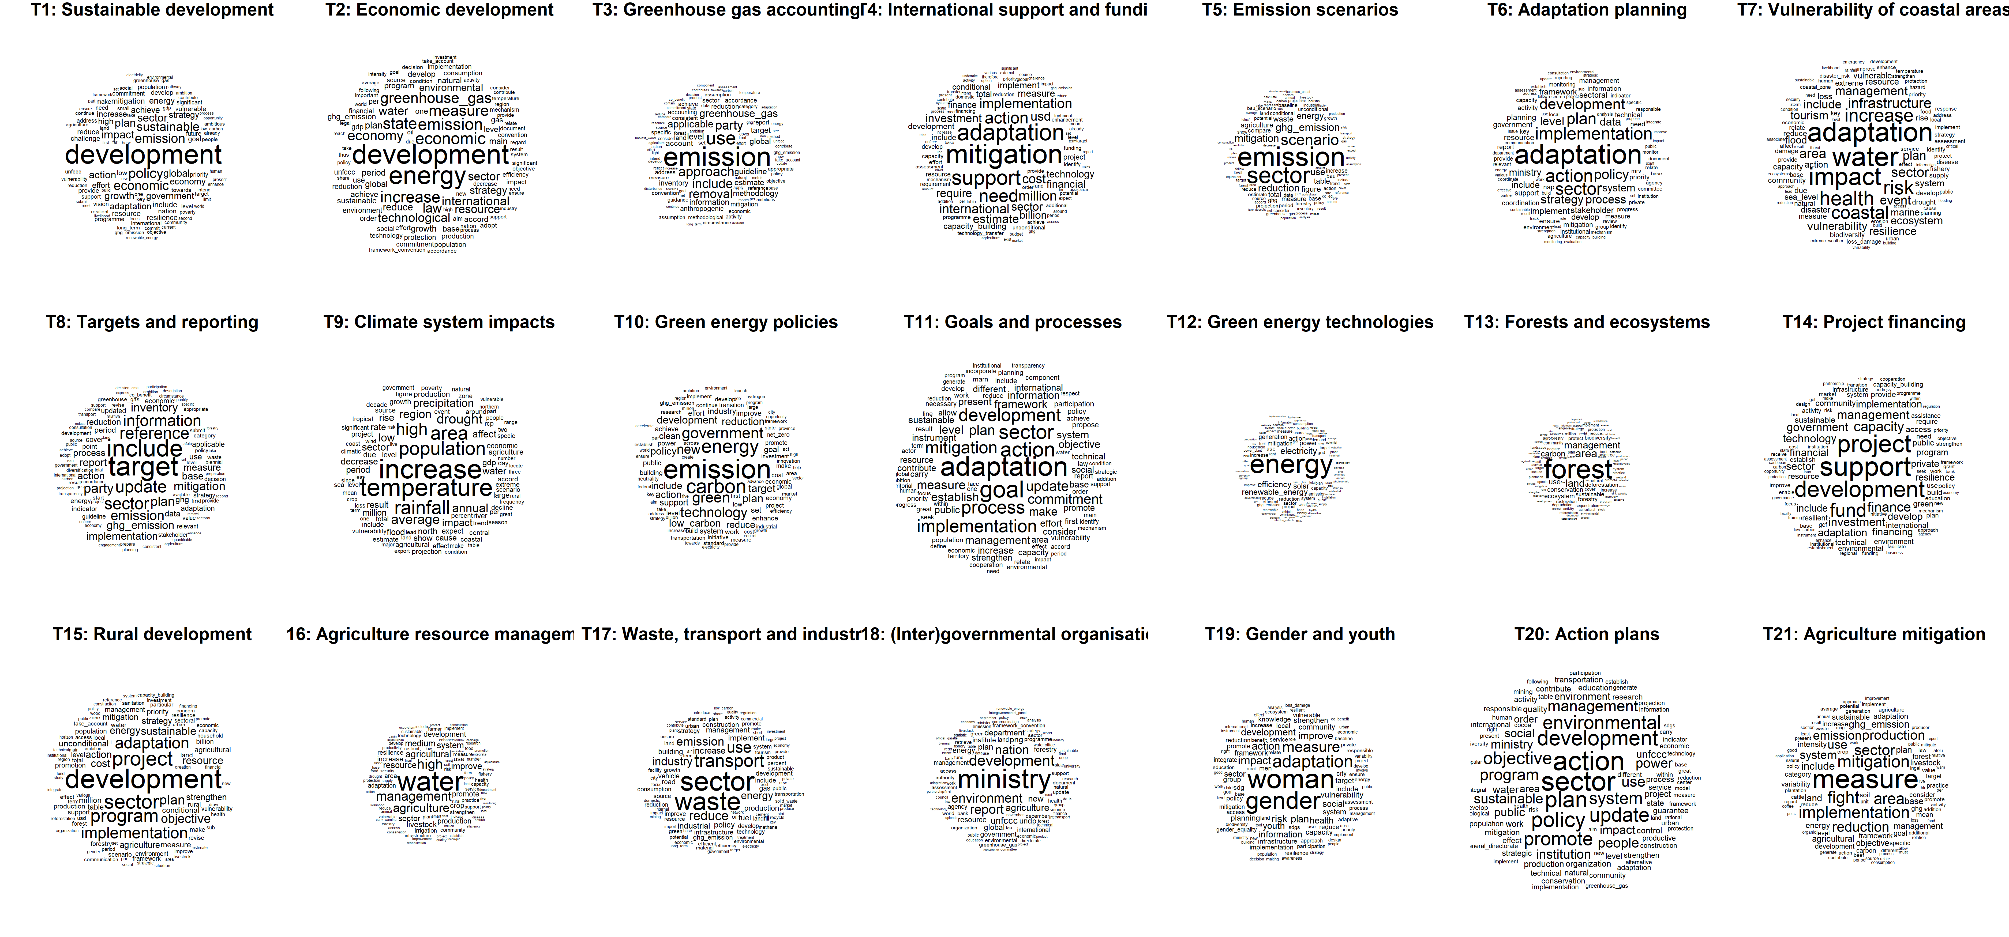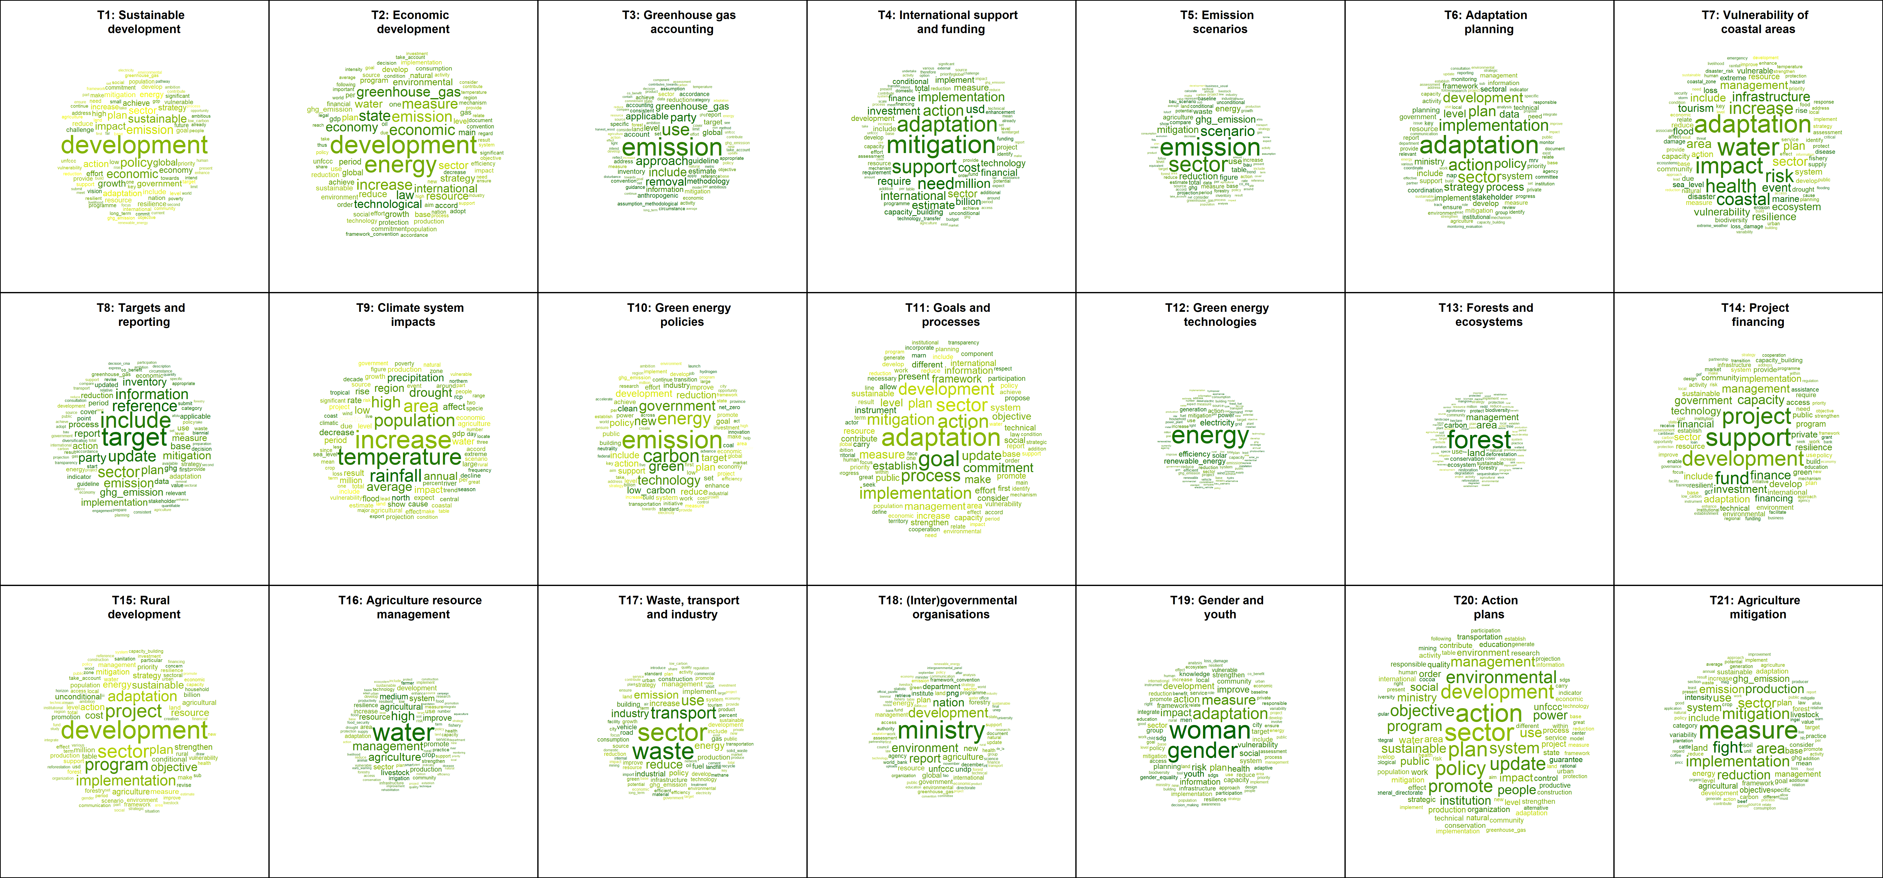

exploring correlations between topic proportionas in documents and the additional data

## Warning: package 'Hmisc' was built under R version 4.3.2

##   
## Attaching package: 'Hmisc'

## The following object is masked from 'package:ape':  
##   
## zoom

## The following objects are masked from 'package:dplyr':  
##   
## src, summarize

## The following objects are masked from 'package:plyr':  
##   
## is.discrete, summarize

## The following objects are masked from 'package:base':  
##   
## format.pval, units

## Warning: package 'quantreg' was built under R version 4.3.2

## Loading required package: SparseM

##   
## Attaching package: 'SparseM'

## The following object is masked from 'package:base':  
##   
## backsolve

##   
## Attaching package: 'quantreg'

## The following object is masked from 'package:Hmisc':  
##   
## latex

## Warning in text.default(pos.xlabel[, 1], pos.xlabel[, 2], newcolnames, srt =  
## tl.srt, : "cl.lim" is not a graphical parameter

## Warning in text.default(pos.ylabel[, 1], pos.ylabel[, 2], newrownames, col =  
## tl.col, : "cl.lim" is not a graphical parameter

## Warning in title(title, ...): "cl.lim" is not a graphical parameter

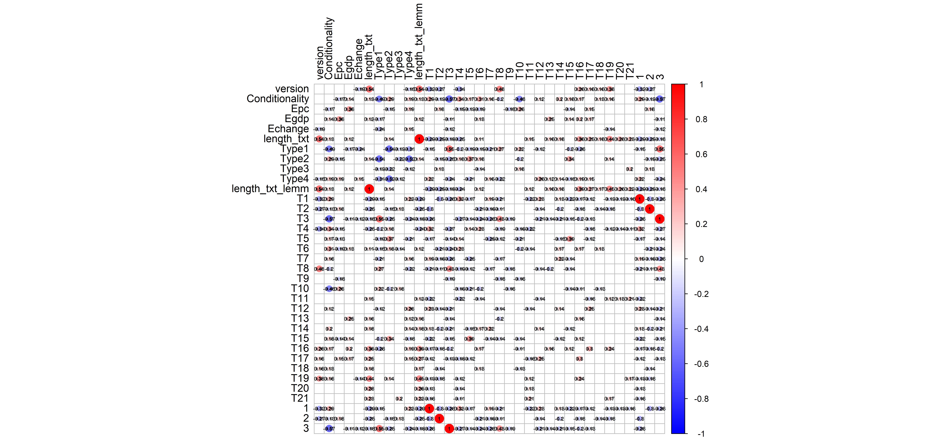

## Loading required package: carData

##   
## Attaching package: 'car'

## The following object is masked from 'package:dplyr':  
##   
## recode

##   
## Call:  
## lm(formula = y ~ data_lemmatized$version + data_lemmatized$Conditionality +   
## data_lemmatized$Epc + data_lemmatized$Egdp + data_lemmatized$Echange +   
## data_lemmatized$Vulnerability + data_lemmatized$GDP + data_lemmatized$NRR +   
## data_lemmatized$length_txt)  
##   
## Residuals:  
## Min 1Q Median 3Q Max   
## -0.25504 -0.08227 -0.01965 0.06533 0.40605   
##   
## Coefficients:  
## Estimate Std. Error t value Pr(>|t|)   
## (Intercept) -0.0957734 0.0474848 -2.017 0.044658 *   
## data_lemmatized$version -0.0485547 0.0165304 -2.937 0.003586 **   
## data_lemmatized$Conditionality 0.0907766 0.0227396 3.992 8.38e-05 ***  
## data_lemmatized$Epc 0.0015480 0.0007885 1.963 0.050601 .   
## data_lemmatized$Egdp -0.0049308 0.0023206 -2.125 0.034480 *   
## data_lemmatized$Echange -0.0089740 0.0089569 -1.002 0.317256   
## data_lemmatized$Vulnerability 0.4541115 0.0988345 4.595 6.56e-06 ***  
## data_lemmatized$GDP 0.6944081 0.6641227 1.046 0.296647   
## data_lemmatized$NRR -0.0027271 0.0008298 -3.286 0.001144 **   
## data_lemmatized$length_txt -0.0038216 0.0009955 -3.839 0.000153 ***  
## ---  
## Signif. codes: 0 '***' 0.001 '**' 0.01 '*' 0.05 '.' 0.1 ' ' 1  
##   
## Residual standard error: 0.1123 on 280 degrees of freedom  
## (19 observations deleted due to missingness)  
## Multiple R-squared: 0.297, Adjusted R-squared: 0.2744   
## F-statistic: 13.14 on 9 and 280 DF, p-value: < 2.2e-16  
##   
##   
## Call:  
## lm(formula = y ~ data_lemmatized$version + data_lemmatized$Conditionality +   
## data_lemmatized$Epc + data_lemmatized$Egdp + data_lemmatized$Echange +   
## data_lemmatized$Vulnerability + data_lemmatized$GDP + data_lemmatized$NRR +   
## data_lemmatized$length_txt)  
##   
## Residuals:  
## Min 1Q Median 3Q Max   
## -0.33699 -0.06640 -0.01611 0.03714 0.60081   
##   
## Coefficients:  
## Estimate Std. Error t value Pr(>|t|)   
## (Intercept) 0.5074868 0.0481859 10.532 < 2e-16 ***  
## data_lemmatized$version -0.0499306 0.0167745 -2.977 0.00317 **   
## data_lemmatized$Conditionality -0.0131723 0.0230753 -0.571 0.56857   
## data_lemmatized$Epc 0.0017847 0.0008001 2.231 0.02650 *   
## data_lemmatized$Egdp -0.0032661 0.0023549 -1.387 0.16655   
## data_lemmatized$Echange 0.0121149 0.0090892 1.333 0.18365   
## data_lemmatized$Vulnerability -0.8114714 0.1002937 -8.091 1.81e-14 ***  
## data_lemmatized$GDP -3.4301484 0.6739282 -5.090 6.59e-07 ***  
## data_lemmatized$NRR 0.0044356 0.0008421 5.267 2.76e-07 ***  
## data_lemmatized$length_txt -0.0020772 0.0010102 -2.056 0.04069 *   
## ---  
## Signif. codes: 0 '***' 0.001 '**' 0.01 '*' 0.05 '.' 0.1 ' ' 1  
##   
## Residual standard error: 0.1139 on 280 degrees of freedom  
## (19 observations deleted due to missingness)  
## Multiple R-squared: 0.3551, Adjusted R-squared: 0.3344   
## F-statistic: 17.13 on 9 and 280 DF, p-value: < 2.2e-16  
##   
##   
## Call:  
## lm(formula = y ~ data_lemmatized$version + data_lemmatized$Conditionality +   
## data_lemmatized$Epc + data_lemmatized$Egdp + data_lemmatized$Echange +   
## data_lemmatized$Vulnerability + data_lemmatized$GDP + data_lemmatized$NRR +   
## data_lemmatized$length_txt)  
##   
## Residuals:  
## Min 1Q Median 3Q Max   
## -0.33224 -0.04693 -0.01316 0.03108 0.55897   
##   
## Coefficients:  
## Estimate Std. Error t value Pr(>|t|)   
## (Intercept) 0.2775324 0.0459356 6.042 4.84e-09 ***  
## data_lemmatized$version 0.0516303 0.0159911 3.229 0.001392 **   
## data_lemmatized$Conditionality -0.1113215 0.0219977 -5.061 7.58e-07 ***  
## data_lemmatized$Epc -0.0030528 0.0007627 -4.002 8.03e-05 ***  
## data_lemmatized$Egdp 0.0059825 0.0022449 2.665 0.008148 **   
## data_lemmatized$Echange -0.0079215 0.0086647 -0.914 0.361387   
## data_lemmatized$Vulnerability -0.2707328 0.0956100 -2.832 0.004967 **   
## data_lemmatized$GDP 3.6625615 0.6424554 5.701 3.02e-08 ***  
## data_lemmatized$NRR -0.0008235 0.0008028 -1.026 0.305855   
## data_lemmatized$length_txt -0.0037488 0.0009631 -3.893 0.000124 ***  
## ---  
## Signif. codes: 0 '***' 0.001 '**' 0.01 '*' 0.05 '.' 0.1 ' ' 1  
##   
## Residual standard error: 0.1086 on 280 degrees of freedom  
## (19 observations deleted due to missingness)  
## Multiple R-squared: 0.4872, Adjusted R-squared: 0.4708   
## F-statistic: 29.56 on 9 and 280 DF, p-value: < 2.2e-16  
##   
##   
## Call:  
## lm(formula = y ~ data_lemmatized$version + data_lemmatized$Conditionality +   
## data_lemmatized$Epc + data_lemmatized$Egdp + data_lemmatized$Echange +   
## data_lemmatized$Vulnerability + data_lemmatized$GDP + data_lemmatized$NRR +   
## data_lemmatized$length_txt)  
##   
## Residuals:  
## Min 1Q Median 3Q Max   
## -0.11067 -0.03965 -0.01289 0.02722 0.30478   
##   
## Coefficients:  
## Estimate Std. Error t value Pr(>|t|)   
## (Intercept) 3.748e-02 2.742e-02 1.367 0.17271   
## data_lemmatized$version -3.653e-02 9.544e-03 -3.827 0.00016 ***  
## data_lemmatized$Conditionality 3.836e-02 1.313e-02 2.922 0.00376 **   
## data_lemmatized$Epc -3.424e-04 4.552e-04 -0.752 0.45265   
## data_lemmatized$Egdp 1.810e-03 1.340e-03 1.351 0.17781   
## data_lemmatized$Echange 2.012e-05 5.171e-03 0.004 0.99690   
## data_lemmatized$Vulnerability 9.522e-02 5.706e-02 1.669 0.09629 .   
## data_lemmatized$GDP -5.903e-01 3.834e-01 -1.539 0.12482   
## data_lemmatized$NRR -7.458e-04 4.791e-04 -1.557 0.12068   
## data_lemmatized$length_txt -1.653e-03 5.748e-04 -2.876 0.00433 **   
## ---  
## Signif. codes: 0 '***' 0.001 '**' 0.01 '*' 0.05 '.' 0.1 ' ' 1  
##   
## Residual standard error: 0.06482 on 280 degrees of freedom  
## (19 observations deleted due to missingness)  
## Multiple R-squared: 0.2885, Adjusted R-squared: 0.2657   
## F-statistic: 12.62 on 9 and 280 DF, p-value: < 2.2e-16  
##   
##   
## Call:  
## lm(formula = y ~ data_lemmatized$version + data_lemmatized$Conditionality +   
## data_lemmatized$Epc + data_lemmatized$Egdp + data_lemmatized$Echange +   
## data_lemmatized$Vulnerability + data_lemmatized$GDP + data_lemmatized$NRR +   
## data_lemmatized$length_txt)  
##   
## Residuals:  
## Min 1Q Median 3Q Max   
## -0.09526 -0.04883 -0.02014 0.02545 0.35041   
##   
## Coefficients:  
## Estimate Std. Error t value Pr(>|t|)   
## (Intercept) 5.038e-02 3.201e-02 1.574 0.1166   
## data_lemmatized$version -1.188e-02 1.114e-02 -1.067 0.2871   
## data_lemmatized$Conditionality 1.203e-02 1.533e-02 0.785 0.4331   
## data_lemmatized$Epc -3.203e-04 5.315e-04 -0.603 0.5472   
## data_lemmatized$Egdp 2.549e-04 1.564e-03 0.163 0.8707   
## data_lemmatized$Echange -5.281e-03 6.037e-03 -0.875 0.3825   
## data_lemmatized$Vulnerability 5.029e-02 6.662e-02 0.755 0.4509   
## data_lemmatized$GDP -7.857e-01 4.477e-01 -1.755 0.0803 .  
## data_lemmatized$NRR 2.918e-04 5.594e-04 0.522 0.6023   
## data_lemmatized$length_txt -1.642e-05 6.710e-04 -0.024 0.9805   
## ---  
## Signif. codes: 0 '***' 0.001 '**' 0.01 '*' 0.05 '.' 0.1 ' ' 1  
##   
## Residual standard error: 0.07567 on 280 degrees of freedom  
## (19 observations deleted due to missingness)  
## Multiple R-squared: 0.07803, Adjusted R-squared: 0.0484   
## F-statistic: 2.633 on 9 and 280 DF, p-value: 0.00613  
##   
##   
## Call:  
## lm(formula = y ~ data_lemmatized$version + data_lemmatized$Conditionality +   
## data_lemmatized$Epc + data_lemmatized$Egdp + data_lemmatized$Echange +   
## data_lemmatized$Vulnerability + data_lemmatized$GDP + data_lemmatized$NRR +   
## data_lemmatized$length_txt)  
##   
## Residuals:  
## Min 1Q Median 3Q Max   
## -0.09909 -0.04055 -0.01545 0.02279 0.30653   
##   
## Coefficients:  
## Estimate Std. Error t value Pr(>|t|)   
## (Intercept) 0.0090000 0.0259614 0.347 0.7291   
## data_lemmatized$version 0.0069792 0.0090377 0.772 0.4406   
## data_lemmatized$Conditionality 0.0314445 0.0124324 2.529 0.0120 *  
## data_lemmatized$Epc -0.0008762 0.0004311 -2.033 0.0430 *  
## data_lemmatized$Egdp 0.0023818 0.0012688 1.877 0.0615 .  
## data_lemmatized$Echange 0.0021744 0.0048970 0.444 0.6574   
## data_lemmatized$Vulnerability 0.0596334 0.0540359 1.104 0.2707   
## data_lemmatized$GDP -0.1688155 0.3630964 -0.465 0.6423   
## data_lemmatized$NRR -0.0002443 0.0004537 -0.538 0.5907   
## data_lemmatized$length_txt 0.0004675 0.0005443 0.859 0.3912   
## ---  
## Signif. codes: 0 '***' 0.001 '**' 0.01 '*' 0.05 '.' 0.1 ' ' 1  
##   
## Residual standard error: 0.06138 on 280 degrees of freedom  
## (19 observations deleted due to missingness)  
## Multiple R-squared: 0.1506, Adjusted R-squared: 0.1233   
## F-statistic: 5.514 on 9 and 280 DF, p-value: 5.412e-07  
##   
##   
## Call:  
## lm(formula = y ~ data_lemmatized$version + data_lemmatized$Conditionality +   
## data_lemmatized$Epc + data_lemmatized$Egdp + data_lemmatized$Echange +   
## data_lemmatized$Vulnerability + data_lemmatized$GDP + data_lemmatized$NRR +   
## data_lemmatized$length_txt)  
##   
## Residuals:  
## Min 1Q Median 3Q Max   
## -0.10572 -0.04787 -0.02005 0.01988 0.33588   
##   
## Coefficients:  
## Estimate Std. Error t value Pr(>|t|)   
## (Intercept) -0.0205416 0.0291616 -0.704 0.48176   
## data_lemmatized$version -0.0093550 0.0101517 -0.922 0.35757   
## data_lemmatized$Conditionality 0.0397913 0.0139649 2.849 0.00471 **  
## data_lemmatized$Epc 0.0007432 0.0004842 1.535 0.12596   
## data_lemmatized$Egdp -0.0031689 0.0014251 -2.224 0.02697 *   
## data_lemmatized$Echange -0.0021051 0.0055007 -0.383 0.70224   
## data_lemmatized$Vulnerability 0.0930829 0.0606966 1.534 0.12626   
## data_lemmatized$GDP 0.5757832 0.4078537 1.412 0.15914   
## data_lemmatized$NRR -0.0003104 0.0005096 -0.609 0.54300   
## data_lemmatized$length_txt 0.0007012 0.0006114 1.147 0.25238   
## ---  
## Signif. codes: 0 '***' 0.001 '**' 0.01 '*' 0.05 '.' 0.1 ' ' 1  
##   
## Residual standard error: 0.06894 on 280 degrees of freedom  
## (19 observations deleted due to missingness)  
## Multiple R-squared: 0.06878, Adjusted R-squared: 0.03885   
## F-statistic: 2.298 on 9 and 280 DF, p-value: 0.01672  
##   
##   
## Call:  
## lm(formula = y ~ data_lemmatized$version + data_lemmatized$Conditionality +   
## data_lemmatized$Epc + data_lemmatized$Egdp + data_lemmatized$Echange +   
## data_lemmatized$Vulnerability + data_lemmatized$GDP + data_lemmatized$NRR +   
## data_lemmatized$length_txt)  
##   
## Residuals:  
## Min 1Q Median 3Q Max   
## -0.123635 -0.026582 -0.006959 0.020602 0.275605   
##   
## Coefficients:  
## Estimate Std. Error t value Pr(>|t|)   
## (Intercept) 0.0904545 0.0236755 3.821 0.000164 ***  
## data_lemmatized$version 0.1099267 0.0082419 13.338 < 2e-16 ***  
## data_lemmatized$Conditionality -0.0178335 0.0113377 -1.573 0.116863   
## data_lemmatized$Epc -0.0006649 0.0003931 -1.691 0.091904 .   
## data_lemmatized$Egdp 0.0007207 0.0011570 0.623 0.533850   
## data_lemmatized$Echange 0.0038753 0.0044658 0.868 0.386265   
## data_lemmatized$Vulnerability -0.0849294 0.0492779 -1.723 0.085906 .   
## data_lemmatized$GDP -0.0278910 0.3311247 -0.084 0.932933   
## data_lemmatized$NRR -0.0005873 0.0004137 -1.420 0.156858   
## data_lemmatized$length_txt -0.0037968 0.0004964 -7.649 3.26e-13 ***  
## ---  
## Signif. codes: 0 '***' 0.001 '**' 0.01 '*' 0.05 '.' 0.1 ' ' 1  
##   
## Residual standard error: 0.05597 on 280 degrees of freedom  
## (19 observations deleted due to missingness)  
## Multiple R-squared: 0.4274, Adjusted R-squared: 0.409   
## F-statistic: 23.22 on 9 and 280 DF, p-value: < 2.2e-16  
##   
##   
## Call:  
## lm(formula = y ~ data_lemmatized$version + data_lemmatized$Conditionality +   
## data_lemmatized$Epc + data_lemmatized$Egdp + data_lemmatized$Echange +   
## data_lemmatized$Vulnerability + data_lemmatized$GDP + data_lemmatized$NRR +   
## data_lemmatized$length_txt)  
##   
## Residuals:  
## Min 1Q Median 3Q Max   
## -0.09083 -0.03724 -0.01776 0.02476 0.64562   
##   
## Coefficients:  
## Estimate Std. Error t value Pr(>|t|)   
## (Intercept) 0.0040745 0.0299506 0.136 0.8919   
## data_lemmatized$version -0.0174237 0.0104264 -1.671 0.0958 .  
## data_lemmatized$Conditionality -0.0207625 0.0143428 -1.448 0.1489   
## data_lemmatized$Epc -0.0009034 0.0004973 -1.817 0.0704 .  
## data_lemmatized$Egdp -0.0002281 0.0014637 -0.156 0.8763   
## data_lemmatized$Echange -0.0045463 0.0056495 -0.805 0.4217   
## data_lemmatized$Vulnerability 0.1555721 0.0623389 2.496 0.0132 *  
## data_lemmatized$GDP -0.2445607 0.4188892 -0.584 0.5598   
## data_lemmatized$NRR 0.0008546 0.0005234 1.633 0.1036   
## data_lemmatized$length_txt 0.0005597 0.0006279 0.891 0.3735   
## ---  
## Signif. codes: 0 '***' 0.001 '**' 0.01 '*' 0.05 '.' 0.1 ' ' 1  
##   
## Residual standard error: 0.07081 on 280 degrees of freedom  
## (19 observations deleted due to missingness)  
## Multiple R-squared: 0.09344, Adjusted R-squared: 0.0643   
## F-statistic: 3.206 on 9 and 280 DF, p-value: 0.001028  
##   
##   
## Call:  
## lm(formula = y ~ data_lemmatized$version + data_lemmatized$Conditionality +   
## data_lemmatized$Epc + data_lemmatized$Egdp + data_lemmatized$Echange +   
## data_lemmatized$Vulnerability + data_lemmatized$GDP + data_lemmatized$NRR +   
## data_lemmatized$length_txt)  
##   
## Residuals:  
## Min 1Q Median 3Q Max   
## -0.21239 -0.02362 -0.00642 0.00676 0.63426   
##   
## Coefficients:  
## Estimate Std. Error t value Pr(>|t|)   
## (Intercept) 0.0581640 0.0381806 1.523 0.12879   
## data_lemmatized$version 0.0208025 0.0132914 1.565 0.11869   
## data_lemmatized$Conditionality -0.0987296 0.0182839 -5.400 1.43e-07 ***  
## data_lemmatized$Epc 0.0014446 0.0006340 2.279 0.02344 *   
## data_lemmatized$Egdp -0.0028195 0.0018659 -1.511 0.13190   
## data_lemmatized$Echange -0.0013779 0.0072019 -0.191 0.84840   
## data_lemmatized$Vulnerability 0.0802056 0.0794686 1.009 0.31371   
## data_lemmatized$GDP 1.5913079 0.5339930 2.980 0.00314 **   
## data_lemmatized$NRR -0.0001381 0.0006672 -0.207 0.83617   
## data_lemmatized$length_txt -0.0001814 0.0008005 -0.227 0.82089   
## ---  
## Signif. codes: 0 '***' 0.001 '**' 0.01 '*' 0.05 '.' 0.1 ' ' 1  
##   
## Residual standard error: 0.09027 on 280 degrees of freedom  
## (19 observations deleted due to missingness)  
## Multiple R-squared: 0.3325, Adjusted R-squared: 0.311   
## F-statistic: 15.5 on 9 and 280 DF, p-value: < 2.2e-16  
##   
##   
## Call:  
## lm(formula = y ~ data_lemmatized$version + data_lemmatized$Conditionality +   
## data_lemmatized$Epc + data_lemmatized$Egdp + data_lemmatized$Echange +   
## data_lemmatized$Vulnerability + data_lemmatized$GDP + data_lemmatized$NRR +   
## data_lemmatized$length_txt)  
##   
## Residuals:  
## Min 1Q Median 3Q Max   
## -0.14767 -0.05161 -0.02669 -0.00169 0.66211   
##   
## Coefficients:  
## Estimate Std. Error t value Pr(>|t|)   
## (Intercept) 1.819e-01 4.575e-02 3.977 8.9e-05 ***  
## data_lemmatized$version -5.619e-03 1.593e-02 -0.353 0.72450   
## data_lemmatized$Conditionality 4.409e-03 2.191e-02 0.201 0.84064   
## data_lemmatized$Epc -2.213e-06 7.597e-04 -0.003 0.99768   
## data_lemmatized$Egdp -5.901e-04 2.236e-03 -0.264 0.79204   
## data_lemmatized$Echange 6.537e-03 8.630e-03 0.757 0.44939   
## data_lemmatized$Vulnerability -3.106e-01 9.522e-02 -3.261 0.00125 **   
## data_lemmatized$GDP -1.272e+00 6.399e-01 -1.987 0.04788 *   
## data_lemmatized$NRR -1.089e-03 7.995e-04 -1.362 0.17424   
## data_lemmatized$length_txt 2.506e-03 9.592e-04 2.612 0.00948 **   
## ---  
## Signif. codes: 0 '***' 0.001 '**' 0.01 '*' 0.05 '.' 0.1 ' ' 1  
##   
## Residual standard error: 0.1082 on 280 degrees of freedom  
## (19 observations deleted due to missingness)  
## Multiple R-squared: 0.08723, Adjusted R-squared: 0.05789   
## F-statistic: 2.973 on 9 and 280 DF, p-value: 0.002143  
##   
##   
## Call:  
## lm(formula = y ~ data_lemmatized$version + data_lemmatized$Conditionality +   
## data_lemmatized$Epc + data_lemmatized$Egdp + data_lemmatized$Echange +   
## data_lemmatized$Vulnerability + data_lemmatized$GDP + data_lemmatized$NRR +   
## data_lemmatized$length_txt)  
##   
## Residuals:  
## Min 1Q Median 3Q Max   
## -0.07763 -0.02555 -0.01107 0.01387 0.26956   
##   
## Coefficients:  
## Estimate Std. Error t value Pr(>|t|)   
## (Intercept) -0.0236935 0.0177682 -1.333 0.183459   
## data_lemmatized$version -0.0160356 0.0061855 -2.592 0.010029 *   
## data_lemmatized$Conditionality 0.0093771 0.0085089 1.102 0.271391   
## data_lemmatized$Epc 0.0008129 0.0002950 2.755 0.006246 **   
## data_lemmatized$Egdp -0.0012486 0.0008683 -1.438 0.151566   
## data_lemmatized$Echange -0.0013517 0.0033516 -0.403 0.687043   
## data_lemmatized$Vulnerability 0.1059064 0.0369826 2.864 0.004504 **   
## data_lemmatized$GDP 0.2663073 0.2485060 1.072 0.284808   
## data_lemmatized$NRR -0.0004357 0.0003105 -1.403 0.161665   
## data_lemmatized$length_txt 0.0012842 0.0003725 3.447 0.000653 ***  
## ---  
## Signif. codes: 0 '***' 0.001 '**' 0.01 '*' 0.05 '.' 0.1 ' ' 1  
##   
## Residual standard error: 0.04201 on 280 degrees of freedom  
## (19 observations deleted due to missingness)  
## Multiple R-squared: 0.09681, Adjusted R-squared: 0.06778   
## F-statistic: 3.335 on 9 and 280 DF, p-value: 0.0006833  
##   
##   
## Call:  
## lm(formula = y ~ data_lemmatized$version + data_lemmatized$Conditionality +   
## data_lemmatized$Epc + data_lemmatized$Egdp + data_lemmatized$Echange +   
## data_lemmatized$Vulnerability + data_lemmatized$GDP + data_lemmatized$NRR +   
## data_lemmatized$length_txt)  
##   
## Residuals:  
## Min 1Q Median 3Q Max   
## -0.05249 -0.02373 -0.01325 0.00953 0.23276   
##   
## Coefficients:  
## Estimate Std. Error t value Pr(>|t|)   
## (Intercept) 3.165e-02 1.711e-02 1.850 0.0654 .  
## data_lemmatized$version -5.231e-03 5.957e-03 -0.878 0.3807   
## data_lemmatized$Conditionality -1.257e-02 8.195e-03 -1.534 0.1261   
## data_lemmatized$Epc 4.216e-04 2.841e-04 1.484 0.1390   
## data_lemmatized$Egdp 1.604e-03 8.363e-04 1.918 0.0561 .  
## data_lemmatized$Echange 3.813e-04 3.228e-03 0.118 0.9061   
## data_lemmatized$Vulnerability 1.474e-02 3.562e-02 0.414 0.6793   
## data_lemmatized$GDP -4.968e-01 2.393e-01 -2.076 0.0388 *  
## data_lemmatized$NRR 9.449e-05 2.991e-04 0.316 0.7523   
## data_lemmatized$length_txt 9.060e-04 3.588e-04 2.525 0.0121 *  
## ---  
## Signif. codes: 0 '***' 0.001 '**' 0.01 '*' 0.05 '.' 0.1 ' ' 1  
##   
## Residual standard error: 0.04046 on 280 degrees of freedom  
## (19 observations deleted due to missingness)  
## Multiple R-squared: 0.0899, Adjusted R-squared: 0.06065   
## F-statistic: 3.073 on 9 and 280 DF, p-value: 0.001566  
##   
##   
## Call:  
## lm(formula = y ~ data_lemmatized$version + data_lemmatized$Conditionality +   
## data_lemmatized$Epc + data_lemmatized$Egdp + data_lemmatized$Echange +   
## data_lemmatized$Vulnerability + data_lemmatized$GDP + data_lemmatized$NRR +   
## data_lemmatized$length_txt)  
##   
## Residuals:  
## Min 1Q Median 3Q Max   
## -0.084411 -0.023741 -0.010573 0.008651 0.305913   
##   
## Coefficients:  
## Estimate Std. Error t value Pr(>|t|)   
## (Intercept) -4.430e-02 1.967e-02 -2.252 0.02507 *   
## data_lemmatized$version -3.757e-03 6.846e-03 -0.549 0.58364   
## data_lemmatized$Conditionality 1.899e-02 9.418e-03 2.016 0.04474 *   
## data_lemmatized$Epc 4.938e-05 3.266e-04 0.151 0.87991   
## data_lemmatized$Egdp -8.520e-04 9.611e-04 -0.886 0.37612   
## data_lemmatized$Echange -4.126e-03 3.710e-03 -1.112 0.26698   
## data_lemmatized$Vulnerability 1.083e-01 4.093e-02 2.645 0.00863 **  
## data_lemmatized$GDP 3.007e-01 2.751e-01 1.093 0.27521   
## data_lemmatized$NRR 4.356e-04 3.437e-04 1.267 0.20604   
## data_lemmatized$length_txt 1.299e-03 4.123e-04 3.150 0.00181 **  
## ---  
## Signif. codes: 0 '***' 0.001 '**' 0.01 '*' 0.05 '.' 0.1 ' ' 1  
##   
## Residual standard error: 0.0465 on 280 degrees of freedom  
## (19 observations deleted due to missingness)  
## Multiple R-squared: 0.1197, Adjusted R-squared: 0.09142   
## F-statistic: 4.231 on 9 and 280 DF, p-value: 3.739e-05  
##   
##   
## Call:  
## lm(formula = y ~ data_lemmatized$version + data_lemmatized$Conditionality +   
## data_lemmatized$Epc + data_lemmatized$Egdp + data_lemmatized$Echange +   
## data_lemmatized$Vulnerability + data_lemmatized$GDP + data_lemmatized$NRR +   
## data_lemmatized$length_txt)  
##   
## Residuals:  
## Min 1Q Median 3Q Max   
## -0.13479 -0.04164 -0.01332 0.00573 0.36718   
##   
## Coefficients:  
## Estimate Std. Error t value Pr(>|t|)   
## (Intercept) -0.1184106 0.0336762 -3.516 0.000511 ***  
## data_lemmatized$version -0.0028584 0.0117233 -0.244 0.807547   
## data_lemmatized$Conditionality -0.0004033 0.0161269 -0.025 0.980064   
## data_lemmatized$Epc -0.0010996 0.0005592 -1.967 0.050224 .   
## data_lemmatized$Egdp 0.0038495 0.0016458 2.339 0.020038 *   
## data_lemmatized$Echange -0.0041840 0.0063523 -0.659 0.510656   
## data_lemmatized$Vulnerability 0.3187389 0.0700932 4.547 8.1e-06 ***  
## data_lemmatized$GDP 0.4250863 0.4709946 0.903 0.367552   
## data_lemmatized$NRR 0.0004480 0.0005885 0.761 0.447140   
## data_lemmatized$length_txt 0.0006340 0.0007060 0.898 0.370003   
## ---  
## Signif. codes: 0 '***' 0.001 '**' 0.01 '*' 0.05 '.' 0.1 ' ' 1  
##   
## Residual standard error: 0.07962 on 280 degrees of freedom  
## (19 observations deleted due to missingness)  
## Multiple R-squared: 0.1695, Adjusted R-squared: 0.1428   
## F-statistic: 6.347 on 9 and 280 DF, p-value: 3.443e-08  
##   
##   
## Call:  
## lm(formula = y ~ data_lemmatized$version + data_lemmatized$Conditionality +   
## data_lemmatized$Epc + data_lemmatized$Egdp + data_lemmatized$Echange +   
## data_lemmatized$Vulnerability + data_lemmatized$GDP + data_lemmatized$NRR +   
## data_lemmatized$length_txt)  
##   
## Residuals:  
## Min 1Q Median 3Q Max   
## -0.07503 -0.02209 -0.01028 0.01058 0.27233   
##   
## Coefficients:  
## Estimate Std. Error t value Pr(>|t|)   
## (Intercept) -0.0173374 0.0166566 -1.041 0.2988   
## data_lemmatized$version 0.0101245 0.0057985 1.746 0.0819 .   
## data_lemmatized$Conditionality -0.0082316 0.0079765 -1.032 0.3030   
## data_lemmatized$Epc -0.0002130 0.0002766 -0.770 0.4420   
## data_lemmatized$Egdp 0.0014377 0.0008140 1.766 0.0785 .   
## data_lemmatized$Echange 0.0053318 0.0031419 1.697 0.0908 .   
## data_lemmatized$Vulnerability 0.0898277 0.0346689 2.591 0.0101 *   
## data_lemmatized$GDP -0.2872369 0.2329593 -1.233 0.2186   
## data_lemmatized$NRR 0.0001262 0.0002911 0.434 0.6649   
## data_lemmatized$length_txt 0.0015659 0.0003492 4.484 1.07e-05 ***  
## ---  
## Signif. codes: 0 '***' 0.001 '**' 0.01 '*' 0.05 '.' 0.1 ' ' 1  
##   
## Residual standard error: 0.03938 on 280 degrees of freedom  
## (19 observations deleted due to missingness)  
## Multiple R-squared: 0.2406, Adjusted R-squared: 0.2162   
## F-statistic: 9.859 on 9 and 280 DF, p-value: 3.996e-13  
##   
##   
## Call:  
## lm(formula = y ~ data_lemmatized$version + data_lemmatized$Conditionality +   
## data_lemmatized$Epc + data_lemmatized$Egdp + data_lemmatized$Echange +   
## data_lemmatized$Vulnerability + data_lemmatized$GDP + data_lemmatized$NRR +   
## data_lemmatized$length_txt)  
##   
## Residuals:  
## Min 1Q Median 3Q Max   
## -0.059356 -0.021084 -0.012085 0.007269 0.209229   
##   
## Coefficients:  
## Estimate Std. Error t value Pr(>|t|)   
## (Intercept) 0.0097746 0.0165592 0.590 0.5555   
## data_lemmatized$version 0.0065259 0.0057646 1.132 0.2586   
## data_lemmatized$Conditionality 0.0045503 0.0079299 0.574 0.5666   
## data_lemmatized$Epc 0.0006646 0.0002750 2.417 0.0163 *  
## data_lemmatized$Egdp -0.0015028 0.0008093 -1.857 0.0644 .  
## data_lemmatized$Echange 0.0040023 0.0031235 1.281 0.2011   
## data_lemmatized$Vulnerability -0.0010011 0.0344661 -0.029 0.9768   
## data_lemmatized$GDP 0.0359986 0.2315966 0.155 0.8766   
## data_lemmatized$NRR 0.0005430 0.0002894 1.876 0.0616 .  
## data_lemmatized$length_txt 0.0008492 0.0003472 2.446 0.0151 *  
## ---  
## Signif. codes: 0 '***' 0.001 '**' 0.01 '*' 0.05 '.' 0.1 ' ' 1  
##   
## Residual standard error: 0.03915 on 280 degrees of freedom  
## (19 observations deleted due to missingness)  
## Multiple R-squared: 0.09814, Adjusted R-squared: 0.06915   
## F-statistic: 3.385 on 9 and 280 DF, p-value: 0.0005814  
##   
##   
## Call:  
## lm(formula = y ~ data_lemmatized$version + data_lemmatized$Conditionality +   
## data_lemmatized$Epc + data_lemmatized$Egdp + data_lemmatized$Echange +   
## data_lemmatized$Vulnerability + data_lemmatized$GDP + data_lemmatized$NRR +   
## data_lemmatized$length_txt)  
##   
## Residuals:  
## Min 1Q Median 3Q Max   
## -0.038801 -0.015299 -0.009279 0.002850 0.205246   
##   
## Coefficients:  
## Estimate Std. Error t value Pr(>|t|)  
## (Intercept) -0.0069842 0.0134313 -0.520 0.603  
## data_lemmatized$version 0.0075263 0.0046757 1.610 0.109  
## data_lemmatized$Conditionality 0.0052354 0.0064320 0.814 0.416  
## data_lemmatized$Epc -0.0001132 0.0002230 -0.508 0.612  
## data_lemmatized$Egdp 0.0003850 0.0006564 0.586 0.558  
## data_lemmatized$Echange 0.0011482 0.0025335 0.453 0.651  
## data_lemmatized$Vulnerability 0.0321189 0.0279557 1.149 0.252  
## data_lemmatized$GDP -0.0566668 0.1878495 -0.302 0.763  
## data_lemmatized$NRR 0.0003443 0.0002347 1.467 0.144  
## data_lemmatized$length_txt 0.0003384 0.0002816 1.202 0.230  
##   
## Residual standard error: 0.03175 on 280 degrees of freedom  
## (19 observations deleted due to missingness)  
## Multiple R-squared: 0.07877, Adjusted R-squared: 0.04916   
## F-statistic: 2.66 on 9 and 280 DF, p-value: 0.005644  
##   
##   
## Call:  
## lm(formula = y ~ data_lemmatized$version + data_lemmatized$Conditionality +   
## data_lemmatized$Epc + data_lemmatized$Egdp + data_lemmatized$Echange +   
## data_lemmatized$Vulnerability + data_lemmatized$GDP + data_lemmatized$NRR +   
## data_lemmatized$length_txt)  
##   
## Residuals:  
## Min 1Q Median 3Q Max   
## -0.076918 -0.012420 -0.003477 0.005404 0.279549   
##   
## Coefficients:  
## Estimate Std. Error t value Pr(>|t|)   
## (Intercept) 0.0168897 0.0137207 1.231 0.2194   
## data_lemmatized$version 0.0102765 0.0047764 2.151 0.0323 *   
## data_lemmatized$Conditionality 0.0137201 0.0065706 2.088 0.0377 *   
## data_lemmatized$Epc -0.0001884 0.0002278 -0.827 0.4089   
## data_lemmatized$Egdp 0.0004942 0.0006705 0.737 0.4618   
## data_lemmatized$Echange -0.0047986 0.0025881 -1.854 0.0648 .   
## data_lemmatized$Vulnerability -0.0541388 0.0285582 -1.896 0.0590 .   
## data_lemmatized$GDP -0.0765002 0.1918979 -0.399 0.6905   
## data_lemmatized$NRR -0.0002455 0.0002398 -1.024 0.3067   
## data_lemmatized$length_txt 0.0018445 0.0002877 6.412 6.08e-10 ***  
## ---  
## Signif. codes: 0 '***' 0.001 '**' 0.01 '*' 0.05 '.' 0.1 ' ' 1  
##   
## Residual standard error: 0.03244 on 280 degrees of freedom  
## (19 observations deleted due to missingness)  
## Multiple R-squared: 0.2985, Adjusted R-squared: 0.2759   
## F-statistic: 13.24 on 9 and 280 DF, p-value: < 2.2e-16  
##   
##   
## Call:  
## lm(formula = y ~ data_lemmatized$version + data_lemmatized$Conditionality +   
## data_lemmatized$Epc + data_lemmatized$Egdp + data_lemmatized$Echange +   
## data_lemmatized$Vulnerability + data_lemmatized$GDP + data_lemmatized$NRR +   
## data_lemmatized$length_txt)  
##   
## Residuals:  
## Min 1Q Median 3Q Max   
## -0.024710 -0.007286 -0.003675 0.000185 0.158687   
##   
## Coefficients:  
## Estimate Std. Error t value Pr(>|t|)   
## (Intercept) 1.518e-02 7.804e-03 1.945 0.0528 .  
## data_lemmatized$version -1.556e-03 2.717e-03 -0.573 0.5673   
## data_lemmatized$Conditionality 5.958e-03 3.737e-03 1.594 0.1120   
## data_lemmatized$Epc 2.646e-04 1.296e-04 2.042 0.0421 *  
## data_lemmatized$Egdp -4.038e-04 3.814e-04 -1.059 0.2906   
## data_lemmatized$Echange 2.881e-03 1.472e-03 1.957 0.0513 .  
## data_lemmatized$Vulnerability -3.648e-02 1.624e-02 -2.246 0.0255 *  
## data_lemmatized$GDP -6.295e-02 1.091e-01 -0.577 0.5646   
## data_lemmatized$NRR -1.231e-05 1.364e-04 -0.090 0.9282   
## data_lemmatized$length_txt 4.037e-04 1.636e-04 2.468 0.0142 *  
## ---  
## Signif. codes: 0 '***' 0.001 '**' 0.01 '*' 0.05 '.' 0.1 ' ' 1  
##   
## Residual standard error: 0.01845 on 280 degrees of freedom  
## (19 observations deleted due to missingness)  
## Multiple R-squared: 0.08011, Adjusted R-squared: 0.05054   
## F-statistic: 2.709 on 9 and 280 DF, p-value: 0.004855  
##   
##   
## Call:  
## lm(formula = y ~ data_lemmatized$version + data_lemmatized$Conditionality +   
## data_lemmatized$Epc + data_lemmatized$Egdp + data_lemmatized$Echange +   
## data_lemmatized$Vulnerability + data_lemmatized$GDP + data_lemmatized$NRR +   
## data_lemmatized$length_txt)  
##   
## Residuals:  
## Min 1Q Median 3Q Max   
## -0.06857 -0.01156 -0.00341 0.00466 0.53059   
##   
## Coefficients:  
## Estimate Std. Error t value Pr(>|t|)   
## (Intercept) 3.704e-02 1.650e-02 2.245 0.02554 *   
## data_lemmatized$version -1.506e-02 5.743e-03 -2.622 0.00921 **   
## data_lemmatized$Conditionality 8.380e-03 7.901e-03 1.061 0.28976   
## data_lemmatized$Epc 4.284e-05 2.739e-04 0.156 0.87584   
## data_lemmatized$Egdp 9.067e-05 8.063e-04 0.112 0.91054   
## data_lemmatized$Echange 6.200e-03 3.112e-03 1.992 0.04732 *   
## data_lemmatized$Vulnerability -8.841e-02 3.434e-02 -2.575 0.01055 *   
## data_lemmatized$GDP -5.313e-02 2.307e-01 -0.230 0.81806   
## data_lemmatized$NRR -2.144e-04 2.883e-04 -0.744 0.45771   
## data_lemmatized$length_txt 1.937e-03 3.459e-04 5.600 5.12e-08 ***  
## ---  
## Signif. codes: 0 '***' 0.001 '**' 0.01 '*' 0.05 '.' 0.1 ' ' 1  
##   
## Residual standard error: 0.039 on 280 degrees of freedom  
## (19 observations deleted due to missingness)  
## Multiple R-squared: 0.137, Adjusted R-squared: 0.1093   
## F-statistic: 4.94 on 9 and 280 DF, p-value: 3.618e-06

##   
## Call:  
## lm(formula = y ~ data_lemmatized$version + data_lemmatized$Conditionality +   
## data_lemmatized$Epc + data_lemmatized$Egdp + data_lemmatized$Echange +   
## data_lemmatized$Vulnerability + data_lemmatized$GDP + data_lemmatized$NRR +   
## data_lemmatized$length_txt)  
##   
## Residuals:  
## Min 1Q Median 3Q Max   
## -0.11067 -0.03965 -0.01289 0.02722 0.30478   
##   
## Coefficients:  
## Estimate Std. Error t value Pr(>|t|)   
## (Intercept) 3.748e-02 2.742e-02 1.367 0.17271   
## data_lemmatized$version -3.653e-02 9.544e-03 -3.827 0.00016 ***  
## data_lemmatized$Conditionality 3.836e-02 1.313e-02 2.922 0.00376 **   
## data_lemmatized$Epc -3.424e-04 4.552e-04 -0.752 0.45265   
## data_lemmatized$Egdp 1.810e-03 1.340e-03 1.351 0.17781   
## data_lemmatized$Echange 2.012e-05 5.171e-03 0.004 0.99690   
## data_lemmatized$Vulnerability 9.522e-02 5.706e-02 1.669 0.09629 .   
## data_lemmatized$GDP -5.903e-01 3.834e-01 -1.539 0.12482   
## data_lemmatized$NRR -7.458e-04 4.791e-04 -1.557 0.12068   
## data_lemmatized$length_txt -1.653e-03 5.748e-04 -2.876 0.00433 **   
## ---  
## Signif. codes: 0 '***' 0.001 '**' 0.01 '*' 0.05 '.' 0.1 ' ' 1  
##   
## Residual standard error: 0.06482 on 280 degrees of freedom  
## (19 observations deleted due to missingness)  
## Multiple R-squared: 0.2885, Adjusted R-squared: 0.2657   
## F-statistic: 12.62 on 9 and 280 DF, p-value: < 2.2e-16  
##   
##   
## Call:  
## lm(formula = y ~ data_lemmatized$version + data_lemmatized$Conditionality +   
## data_lemmatized$Epc + data_lemmatized$Egdp + data_lemmatized$Echange +   
## data_lemmatized$Vulnerability + data_lemmatized$GDP + data_lemmatized$NRR +   
## data_lemmatized$length_txt)  
##   
## Residuals:  
## Min 1Q Median 3Q Max   
## -0.09526 -0.04883 -0.02014 0.02545 0.35041   
##   
## Coefficients:  
## Estimate Std. Error t value Pr(>|t|)   
## (Intercept) 5.038e-02 3.201e-02 1.574 0.1166   
## data_lemmatized$version -1.188e-02 1.114e-02 -1.067 0.2871   
## data_lemmatized$Conditionality 1.203e-02 1.533e-02 0.785 0.4331   
## data_lemmatized$Epc -3.203e-04 5.315e-04 -0.603 0.5472   
## data_lemmatized$Egdp 2.549e-04 1.564e-03 0.163 0.8707   
## data_lemmatized$Echange -5.281e-03 6.037e-03 -0.875 0.3825   
## data_lemmatized$Vulnerability 5.029e-02 6.662e-02 0.755 0.4509   
## data_lemmatized$GDP -7.857e-01 4.477e-01 -1.755 0.0803 .  
## data_lemmatized$NRR 2.918e-04 5.594e-04 0.522 0.6023   
## data_lemmatized$length_txt -1.642e-05 6.710e-04 -0.024 0.9805   
## ---  
## Signif. codes: 0 '***' 0.001 '**' 0.01 '*' 0.05 '.' 0.1 ' ' 1  
##   
## Residual standard error: 0.07567 on 280 degrees of freedom  
## (19 observations deleted due to missingness)  
## Multiple R-squared: 0.07803, Adjusted R-squared: 0.0484   
## F-statistic: 2.633 on 9 and 280 DF, p-value: 0.00613  
##   
##   
## Call:  
## lm(formula = y ~ data_lemmatized$version + data_lemmatized$Conditionality +   
## data_lemmatized$Epc + data_lemmatized$Egdp + data_lemmatized$Echange +   
## data_lemmatized$Vulnerability + data_lemmatized$GDP + data_lemmatized$NRR +   
## data_lemmatized$length_txt)  
##   
## Residuals:  
## Min 1Q Median 3Q Max   
## -0.09909 -0.04055 -0.01545 0.02279 0.30653   
##   
## Coefficients:  
## Estimate Std. Error t value Pr(>|t|)   
## (Intercept) 0.0090000 0.0259614 0.347 0.7291   
## data_lemmatized$version 0.0069792 0.0090377 0.772 0.4406   
## data_lemmatized$Conditionality 0.0314445 0.0124324 2.529 0.0120 *  
## data_lemmatized$Epc -0.0008762 0.0004311 -2.033 0.0430 *  
## data_lemmatized$Egdp 0.0023818 0.0012688 1.877 0.0615 .  
## data_lemmatized$Echange 0.0021744 0.0048970 0.444 0.6574   
## data_lemmatized$Vulnerability 0.0596334 0.0540359 1.104 0.2707   
## data_lemmatized$GDP -0.1688155 0.3630964 -0.465 0.6423   
## data_lemmatized$NRR -0.0002443 0.0004537 -0.538 0.5907   
## data_lemmatized$length_txt 0.0004675 0.0005443 0.859 0.3912   
## ---  
## Signif. codes: 0 '***' 0.001 '**' 0.01 '*' 0.05 '.' 0.1 ' ' 1  
##   
## Residual standard error: 0.06138 on 280 degrees of freedom  
## (19 observations deleted due to missingness)  
## Multiple R-squared: 0.1506, Adjusted R-squared: 0.1233   
## F-statistic: 5.514 on 9 and 280 DF, p-value: 5.412e-07  
##   
##   
## Call:  
## lm(formula = y ~ data_lemmatized$version + data_lemmatized$Conditionality +   
## data_lemmatized$Epc + data_lemmatized$Egdp + data_lemmatized$Echange +   
## data_lemmatized$Vulnerability + data_lemmatized$GDP + data_lemmatized$NRR +   
## data_lemmatized$length_txt)  
##   
## Residuals:  
## Min 1Q Median 3Q Max   
## -0.10572 -0.04787 -0.02005 0.01988 0.33588   
##   
## Coefficients:  
## Estimate Std. Error t value Pr(>|t|)   
## (Intercept) -0.0205416 0.0291616 -0.704 0.48176   
## data_lemmatized$version -0.0093550 0.0101517 -0.922 0.35757   
## data_lemmatized$Conditionality 0.0397913 0.0139649 2.849 0.00471 **  
## data_lemmatized$Epc 0.0007432 0.0004842 1.535 0.12596   
## data_lemmatized$Egdp -0.0031689 0.0014251 -2.224 0.02697 *   
## data_lemmatized$Echange -0.0021051 0.0055007 -0.383 0.70224   
## data_lemmatized$Vulnerability 0.0930829 0.0606966 1.534 0.12626   
## data_lemmatized$GDP 0.5757832 0.4078537 1.412 0.15914   
## data_lemmatized$NRR -0.0003104 0.0005096 -0.609 0.54300   
## data_lemmatized$length_txt 0.0007012 0.0006114 1.147 0.25238   
## ---  
## Signif. codes: 0 '***' 0.001 '**' 0.01 '*' 0.05 '.' 0.1 ' ' 1  
##   
## Residual standard error: 0.06894 on 280 degrees of freedom  
## (19 observations deleted due to missingness)  
## Multiple R-squared: 0.06878, Adjusted R-squared: 0.03885   
## F-statistic: 2.298 on 9 and 280 DF, p-value: 0.01672  
##   
##   
## Call:  
## lm(formula = y ~ data_lemmatized$version + data_lemmatized$Conditionality +   
## data_lemmatized$Epc + data_lemmatized$Egdp + data_lemmatized$Echange +   
## data_lemmatized$Vulnerability + data_lemmatized$GDP + data_lemmatized$NRR +   
## data_lemmatized$length_txt)  
##   
## Residuals:  
## Min 1Q Median 3Q Max   
## -0.123635 -0.026582 -0.006959 0.020602 0.275605   
##   
## Coefficients:  
## Estimate Std. Error t value Pr(>|t|)   
## (Intercept) 0.0904545 0.0236755 3.821 0.000164 ***  
## data_lemmatized$version 0.1099267 0.0082419 13.338 < 2e-16 ***  
## data_lemmatized$Conditionality -0.0178335 0.0113377 -1.573 0.116863   
## data_lemmatized$Epc -0.0006649 0.0003931 -1.691 0.091904 .   
## data_lemmatized$Egdp 0.0007207 0.0011570 0.623 0.533850   
## data_lemmatized$Echange 0.0038753 0.0044658 0.868 0.386265   
## data_lemmatized$Vulnerability -0.0849294 0.0492779 -1.723 0.085906 .   
## data_lemmatized$GDP -0.0278910 0.3311247 -0.084 0.932933   
## data_lemmatized$NRR -0.0005873 0.0004137 -1.420 0.156858   
## data_lemmatized$length_txt -0.0037968 0.0004964 -7.649 3.26e-13 ***  
## ---  
## Signif. codes: 0 '***' 0.001 '**' 0.01 '*' 0.05 '.' 0.1 ' ' 1  
##   
## Residual standard error: 0.05597 on 280 degrees of freedom  
## (19 observations deleted due to missingness)  
## Multiple R-squared: 0.4274, Adjusted R-squared: 0.409   
## F-statistic: 23.22 on 9 and 280 DF, p-value: < 2.2e-16  
##   
##   
## Call:  
## lm(formula = y ~ data_lemmatized$version + data_lemmatized$Conditionality +   
## data_lemmatized$Epc + data_lemmatized$Egdp + data_lemmatized$Echange +   
## data_lemmatized$Vulnerability + data_lemmatized$GDP + data_lemmatized$NRR +   
## data_lemmatized$length_txt)  
##   
## Residuals:  
## Min 1Q Median 3Q Max   
## -0.09083 -0.03724 -0.01776 0.02476 0.64562   
##   
## Coefficients:  
## Estimate Std. Error t value Pr(>|t|)   
## (Intercept) 0.0040745 0.0299506 0.136 0.8919   
## data_lemmatized$version -0.0174237 0.0104264 -1.671 0.0958 .  
## data_lemmatized$Conditionality -0.0207625 0.0143428 -1.448 0.1489   
## data_lemmatized$Epc -0.0009034 0.0004973 -1.817 0.0704 .  
## data_lemmatized$Egdp -0.0002281 0.0014637 -0.156 0.8763   
## data_lemmatized$Echange -0.0045463 0.0056495 -0.805 0.4217   
## data_lemmatized$Vulnerability 0.1555721 0.0623389 2.496 0.0132 *  
## data_lemmatized$GDP -0.2445607 0.4188892 -0.584 0.5598   
## data_lemmatized$NRR 0.0008546 0.0005234 1.633 0.1036   
## data_lemmatized$length_txt 0.0005597 0.0006279 0.891 0.3735   
## ---  
## Signif. codes: 0 '***' 0.001 '**' 0.01 '*' 0.05 '.' 0.1 ' ' 1  
##   
## Residual standard error: 0.07081 on 280 degrees of freedom  
## (19 observations deleted due to missingness)  
## Multiple R-squared: 0.09344, Adjusted R-squared: 0.0643   
## F-statistic: 3.206 on 9 and 280 DF, p-value: 0.001028  
##   
##   
## Call:  
## lm(formula = y ~ data_lemmatized$version + data_lemmatized$Conditionality +   
## data_lemmatized$Epc + data_lemmatized$Egdp + data_lemmatized$Echange +   
## data_lemmatized$Vulnerability + data_lemmatized$GDP + data_lemmatized$NRR +   
## data_lemmatized$length_txt)  
##   
## Residuals:  
## Min 1Q Median 3Q Max   
## -0.21239 -0.02362 -0.00642 0.00676 0.63426   
##   
## Coefficients:  
## Estimate Std. Error t value Pr(>|t|)   
## (Intercept) 0.0581640 0.0381806 1.523 0.12879   
## data_lemmatized$version 0.0208025 0.0132914 1.565 0.11869   
## data_lemmatized$Conditionality -0.0987296 0.0182839 -5.400 1.43e-07 ***  
## data_lemmatized$Epc 0.0014446 0.0006340 2.279 0.02344 *   
## data_lemmatized$Egdp -0.0028195 0.0018659 -1.511 0.13190   
## data_lemmatized$Echange -0.0013779 0.0072019 -0.191 0.84840   
## data_lemmatized$Vulnerability 0.0802056 0.0794686 1.009 0.31371   
## data_lemmatized$GDP 1.5913079 0.5339930 2.980 0.00314 **   
## data_lemmatized$NRR -0.0001381 0.0006672 -0.207 0.83617   
## data_lemmatized$length_txt -0.0001814 0.0008005 -0.227 0.82089   
## ---  
## Signif. codes: 0 '***' 0.001 '**' 0.01 '*' 0.05 '.' 0.1 ' ' 1  
##   
## Residual standard error: 0.09027 on 280 degrees of freedom  
## (19 observations deleted due to missingness)  
## Multiple R-squared: 0.3325, Adjusted R-squared: 0.311   
## F-statistic: 15.5 on 9 and 280 DF, p-value: < 2.2e-16

##   
## Pearson's product-moment correlation  
##   
## data: data_lemmatized$irrelevant and data_lemmatized$Echange  
## t = 2.0087, df = 307, p-value = 0.04544  
## alternative hypothesis: true correlation is not equal to 0  
## 95 percent confidence interval:  
## 0.002351577 0.222646523  
## sample estimates:  
## cor   
## 0.1138989

##   
## Pearson's product-moment correlation  
##   
## data: data_lemmatized$relevant and data_lemmatized$Echange  
## t = -2.0087, df = 307, p-value = 0.04544  
## alternative hypothesis: true correlation is not equal to 0  
## 95 percent confidence interval:  
## -0.222646523 -0.002351577  
## sample estimates:  
## cor   
## -0.1138989

The next figure demonstrates co-occurrence of topics showing which pairs of topics tend to be mentioned within the same responses more (red) or less (blue) often.

## Warning in corrplot(M, p.mat = testRes$p, method = "circle", insig = "blank", :  
## p.mat and corr may be not paired, their rownames and colnames are not totally  
## same!

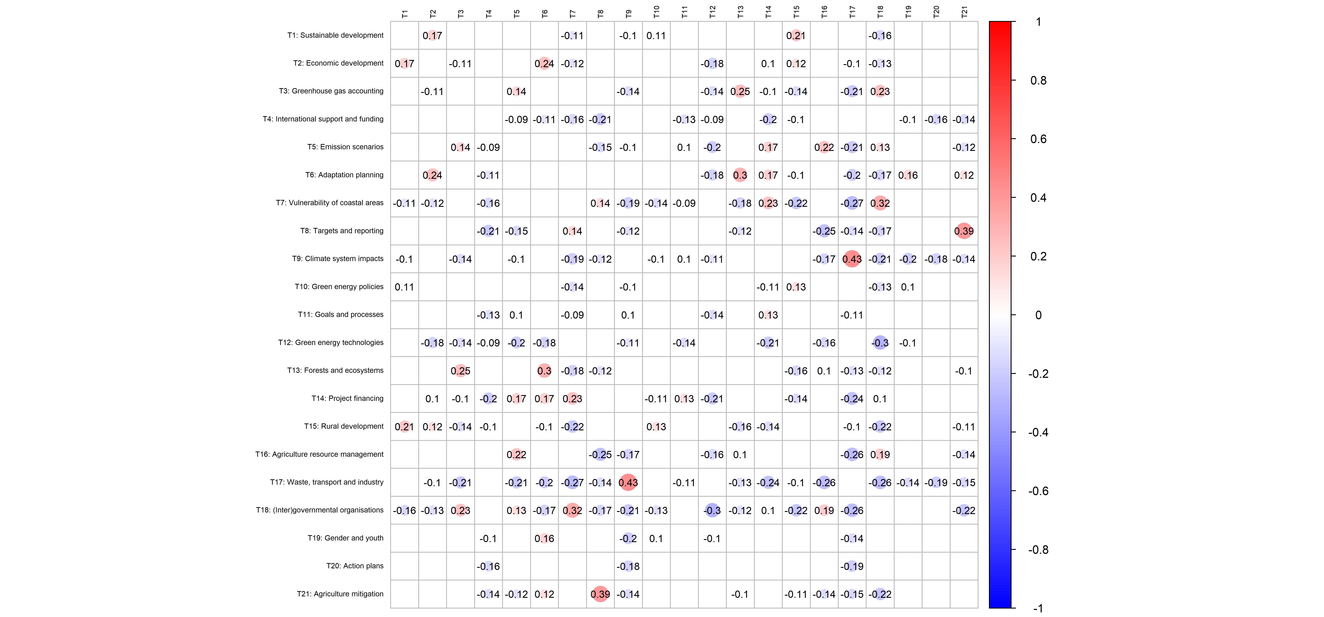

## [1] 22

## [1] 0.2047619

